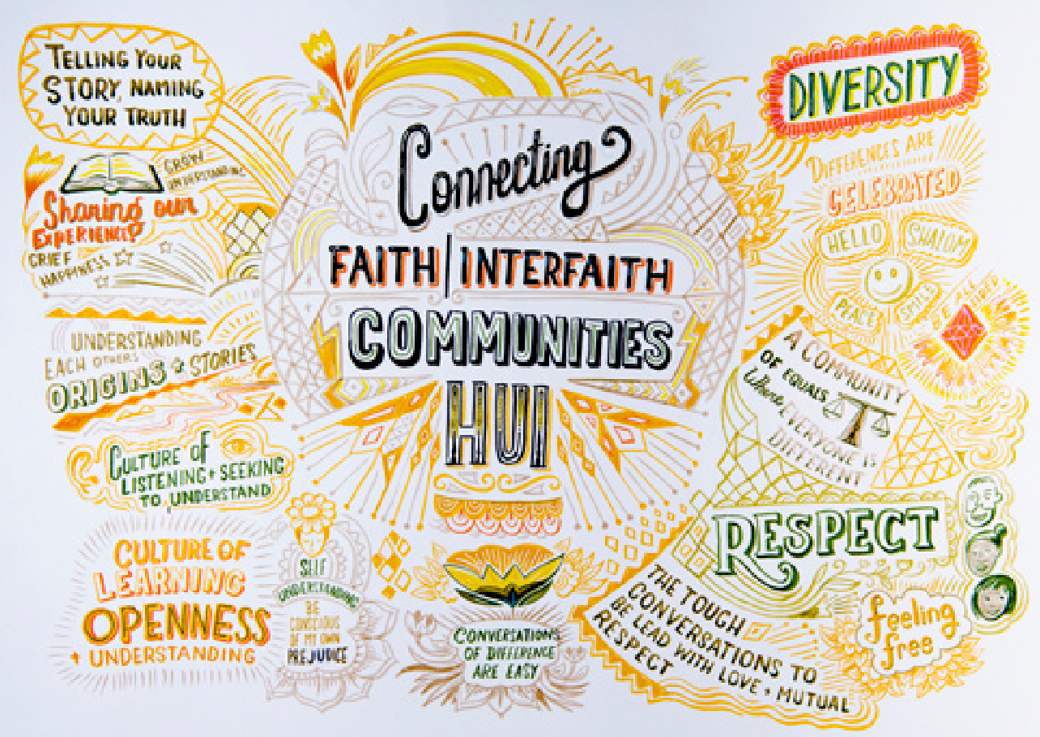

Connecting with
Faith Communities and Interfaith Groups

Growing a socially inclusive Aotearoa New Zealand to counter racism, discrimination and religious intolerance

November 2020

Acknowledgements

We are thankful to the approximately 300 people who attended these Connecting Faith | Interfaith Communities Hui, also noting that a good number of people travelled sometimes considerable distances to be part of the conversation in their region.

Our thanks also to the members of our Reference Group (including representatives from Aotearoa New Zealand’s largest faith communities) who helped develop the programme for the hui.

We also acknowledge the heritage of the interfaith movement in Aotearoa New Zealand, which has worked collaboratively over many years with central and local government,
and wider New Zealand society to advance communication and friendship across faith communities. The hui were intended to build upon this work and extend it to groups who have not historically been involved in this way.

We particularly thank faith groups and Interfaith Councils across the country for their work in assisting us to connect with a wide variety of participants.
Our thanks to all those who took the time to provide feedback on earlier versions of this report. A table of the feedback received can be found as Appendix D.

At each hui, discussions were captured through stunning illustrations, by the League of Live Illustrators. Attendees were able to engage with the illustrators whilst they worked, and the resulting images and statements have been incorporated into the report. The complete
illustrations from each regional hui are attached as Appendix A.

Ngā manaakitanga. Best wishes.

Te Tari Matawaka
Office of Ethnic Communities (OEC)

Executive Director’s Foreword
Kia ora koutou katoa, and warm greetings to you all.
In February and March this year, the Office of Ethnic Communities organised hui in Dunedin, Auckland, Christchurch and Wellington. Around 300 people from faith communities and interfaith organisations from across Aotearoa New Zealand attended these sessions. Our purpose was to foster collaboration between the Government, faith communities and interfaith organisations
in order to continue building a socially inclusive country.

At these meetings, faith and interfaith organisations informed us about the matters that were priorities for the organisations represented
– enhancing collaboration; the importance of an education system that normalises faith and ethnic diversity; the importance of the media in promoting social inclusion; recognising that while Government can be an enabler, community-led actions are important; and
ensuring better connections and collaboration with Government.

A number of participants also shared personal stories, lived experiences, and ideas on how we can build a culture of learning, openness and understanding. The hui highlighted how our diversity, differences in languages and
multiculturalism are strengths to build on and to celebrate. Participants were generous in sharing views about the challenges faced – including the need to build stronger connections with tangata whenua and wider civil society – and how the Government could work harder to build a socially inclusive Aotearoa New Zealand.
This report is a record of those discussions. It weaves together the key themes that came out of the meetings and sets out a number of potential next steps that the Office of Ethnic Communities, community organisations and members of
our communities could take to address the challenges, issues and opportunities raised.

The world has changed considerably since these meetings were held. The COVID-19 pandemic has presented us with new challenges and exacerbated some existing ones. The question of what we can all do to ensure that Aotearoa New Zealand does not provide an environment for discrimination, racism and religious intolerance is more crucial than ever. This report will provide valuable insights into the role that the Office
of Ethnic Communities can play to ensure that Aotearoa New Zealand is a place where diversity is able to flourish and is genuinely valued by all.

I would like to acknowledge and thank all members of our Reference Group who worked with the Office of Ethnic Communities to finalise these hui and this report. My humble thanks also to everyone who attended and contributed to the discussions; I appreciate all your time, energy and expertise. Thanks also to Dr Matt Farry, who facilitated these conversations. I would also like to acknowledge all of you who have contributed extensively to the faith and interfaith movement in Aotearoa New Zealand over many decades; thank you for enriching our discussions and your contributions to this report.

I have found this report valuable in understanding the challenges faced by faith communities and interfaith organisations as I have settled into my new role, and to better understand how the Office of Ethnic Communities may be placed to support the priorities identified.

Ngā mihi nui,

Anusha Guler
Kaiwhakahaere Matua | Executive Director
Te Tari Matawaka | Office of Ethnic Communities

At a Glance: Connecting with Faith Communities and Interfaith Groups:
Growing a socially inclusive
Aotearoa New Zealand to counter racism, discrimination and religious intolerance report (November 2020)
In February and March 2020, the Office of Ethnic Communities (OEC) brought together around 300 people from 50+ faith communities and interfaith groups at four regional Connecting Faith | Interfaith Communities Hui in Dunedin, Auckland,
Christchurch and Wellington. The purpose of the hui was to discuss, identify and agree on actions to promote greater social inclusion and wellbeing, and to counter racism, discrimination and religious intolerance.

Discussions at the hui were wide-ranging as people shared their knowledge, views and ideas for a more socially inclusive Aotearoa New Zealand. An overarching focus was “social inclusion” and how that looked and felt for
participants. This document provides a summary of the discussions held, collates potential opportunities, and suggests possible actions for both the OEC and faith communities, interfaith groups, and wider society based on ideas raised at the hui.

Key themes from the hui
- Enhancing collaboration. There is much important work already happening in Aotearoa New Zealand, either within more established interfaith groups or among faith communities themselves. However, this work is limited, and many attendees would like to see such activities being strengthened and expanded beyond those usually involved.

- The importance of education in normalising faith and ethnic diversity. This includes having an education system which reflects the diversity of its school communities and takes a lead in preparing students for diversity. Attendees see the education system as having a strong role in addressing stereotypes, racism, and discrimination.

- The importance of the media in promoting social inclusion. This includes ensuring messages are delivered to the wider community which represent diverse faith communities accurately, positively and without bias

- Community-led action. Recognising that while Government can be an enabler, locally- led and community driven action is usually better placed to make a difference.

- Better connection and collaboration with Government. There was a desire to strengthen the relationship between
faith communities, interfaith groups, and Government.

Several other issues were also raised, including a desire to form a closer connection with
Māori as tangata whenua; how to best honour those who lost their lives in the 15 March 2019 Christchurch mosque attacks; and how to form better connections with those who do not profess a faith.

Opportunities around these key themes, including potential actions for OEC and potential next steps for faith communities and interfaith groups can be found on pages 17-21 of the full report.

Religious diversity in Aotearoa New Zealand
As outlined in the third edition of the National Statement on Religious Diversity (2019), Government and faith communities have a responsibility to build and maintain positive relationships with each other, and to promote mutual respect, understanding and cooperation.

In Aotearoa New Zealand there are people who identify with faith communities and others who do not. Data from the 2018 Census reflects that whilst 48% of the population do not profess
a religious affiliation, around 45% of the population reflect a diverse array of faiths and beliefs.

Christianity remains the largest overall religious grouping in Aotearoa New Zealand, followed by Hinduism at 2.6%, Islam at 1.2%, and Buddhism and Sikhism at 0.9% each.

These figures reflect not only our religious diversity, but our ethnic diversity as well. For many ethnic communities, expression of faith and culture are almost inseparable and are considered fundamental to their identity and wellbeing.

There are also twelve Interfaith Councils and groups established across the country that provide a forum for inter-religious dialogue and networking opportunities.

However, like many other countries, bigotry, religious intolerance, and racism also reside in pockets of our society – sometimes dangerously so.

Background to the hui
Soon after the 15 March 2019 attacks on two Christchurch mosques, the Prime Minister Rt Hon Jacinda Ardern and the then Minister for Ethnic Communities Hon Jenny Salesa met with faith leaders. The purpose of this initial meeting was to explore how faith communities and Government could work more closely together to grow a socially inclusive Aotearoa New Zealand to counter racism, discrimination and religious intolerance.

Following this, Minister Salesa embarked on a series of dialogues with Muslim communities to hear what they thought Government should do to provide more support. This resulted
in a set of actions identified in the report Conversations with Aotearoa New Zealand’s Muslim Communities, which is available on the OEC website.

A second series of four Connecting Faith | Interfaith Communities Hui were convened in Dunedin, Auckland, Christchurch and Wellington, with around 300 participants from 50+ faith communities and interfaith groups. A list of the organisations that attended and were invited to attend can be found in Appendix C.

OEC worked with a Reference Group, which included representatives from Aotearoa New Zealand’s largest faith communities to develop the programme for the hui.

Each of the largest faiths in Aotearoa New Zealand were then invited to nominate up to five representatives to attend each of the hui.

In recognition of their leadership in the interfaith space, the twelve Interfaith Councils were also invited to nominate up to twelve attendees
for each hui, to reflect the diversity of their membership.

In thinking about who to nominate, OEC advised those nominating to consider as rich a diversity in faith tradition, gender and age as possible. OEC also conveyed a desire to expand the reach of this work beyond those already involved in interfaith work.

More information on the process used to invite attendees and devise the programme can
be found in Appendix B. Appendix B is a FAQ document, which was sent out to the faith communities and interfaith groups that were approached by OEC.

Purpose of the hui
The purpose of the hui was to discuss, identify and agree on actions to promote greater social inclusion and wellbeing, and to counter racism, discrimination and religious intolerance.

OEC saw the hui as a chance for people to make broader connections outside of the communities that they represent and have traditionally connected with. They were an opportunity to identify community-led actions that encourage and facilitate understanding and respect, tackle harms to inclusion, and grow awareness of the benefits of diversity.

OEC recognises that whilst the hui focussed specifically on faith and not ethnicity/culture, for many of our ethnic communities the two are inseparable and are critical parts of both
individual and collective identity and wellbeing.

Capturing content
Conversations at the hui were wide-ranging. They included discussions on social inclusion and how that looked and felt for participants. Attendees shared information about what was already happening across the various parts of Aotearoa New Zealand to build connections and break down barriers. Many focussed on
sharing thoughts and ideas about how to further strengthen social inclusion, religious tolerance and an appreciation of diversity.

OEC committed to summarising the discussions held, collating potential opportunities from each of the hui, and sending these to attendees in the form of this report.

Finally, OEC worked with the League of Live Illustrators (LoLI), who were tasked with creating a visual summary of the hui. The intention was that the illustrations would both enrich this report, and make the conversations captured from the hui more accessible to those who do not speak English as a first language, or simply do not want to read an extensive report.

Many people approached LoLI at the hui to ask to have their ideas or images drawn into the artwork. We hope that you enjoy seeing your ideas and some familiar faces reflected in the illustrations that accompany this report.

What we heard – in summary
Five key themes emerged from the hui.

Enhancing collaboration
There is much important work already happening in Aotearoa New Zealand, either within the more established interfaith groups or among faith communities themselves. However, this work
is limited and many attendees would like to see such activities being strengthened and expanded beyond those usually involved.

The importance of education in normalising faith and ethnic diversity
The desire for a more responsive education system, which reflects the diversity of its school community; takes a lead in preparing students to understand and engage with diversity (global religious perspectives and ethnic/cultural diversity); and includes cultural competencies and awareness, and bias training as part of teacher/kaiako professional development.

The importance of media in promoting social inclusion
Media that represents diverse faith communities accurately and without bias; the need for leaders to be more confident and able to tell their stories and to encourage media to include programmes and messages that promote social inclusion; the importance of ensuring that engagement with media is informed to counter narratives that perpetuate stereotypes, bias and misinformation; and the impact and potential of social media as a means of influence.

Community-led action
A recognition that while Government can be an enabler, communities themselves are usually better placed to make a difference at the grassroots level; and that there are innovative programmes to support social inclusion currently being led at the community level.

Better connection and collaboration with Government
The desire to strengthen the relationship between faith communities, interfaith groups, and Government; to seek more opportunities to work together to foster a greater understanding of faith and ethnic/cultural diversity across civil society; to enable greater exposure of the work of faith communities and interfaith groups in building connections and promoting inclusion; and having access to Government funding to build a stronger faith.

What does social inclusion mean?
Participants were asked to respond to the question: What does social inclusion look like to me? For many, social inclusion meant acceptance, belonging and the freedom to express their faith, ethnicity/culture and beliefs safely, without judgement, discrimination, or threat.

Many talked about wanting to be proud of their faith and ethnicity/culture, rather than feeling the need to moderate what they say and how they dress, speak and act to gain acceptance, or feel welcomed.

They talked about wanting to belong – to feel connected, safe, respected, accepted and understood – and that sometimes a ‘simple smile’ is all that is needed to feel like you belong.

For attendees, “seeing themselves” in leadership roles and positions of power across business, government agencies, media and national and local politics was an important indicator of participation and inclusion, as well as helping to break down stereotypes.

Equal access to employment and educational opportunities was also a recurring theme in discussion about social inclusion.

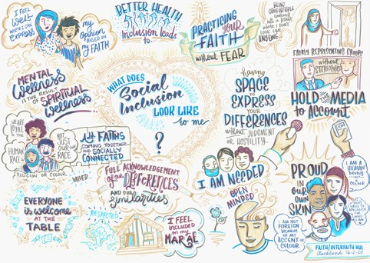

Many expressed that they felt they encountered barriers to employment because of how they looked, or their non-Western sounding names.

Christchurch participants, in particular, noted that they were more vigilant about their safety after the 15 March attacks.

For Muslim women, wearing the hijab in public was considered an additional barrier to
employment and at times led to concerns about their personal safety.

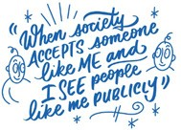

Work underway to grow social inclusion
Participants were asked to respond to the question: What are you currently doing to support social inclusion?

Aotearoa New Zealand’s faith communities and interfaith groups are already engaged across many different areas offering support, education, consciousness raising, advocacy and the opportunity to connect and contribute to society.

Faith communities and interfaith groups are central to a range of activities, which support community connections and inclusion. Some initiatives are focussed on particular groups or demographics (e.g. newcomers and youth)

while others are aimed at more general community building. Some examples include teaching English, organising shared meals and other community connection events, youth programmes (often sports focussed), tree planting projects, walking groups, interfaith choirs and sports programmes.

There is also a particular focus on strengthening connections between different communities such as migrants and iwi Māori.

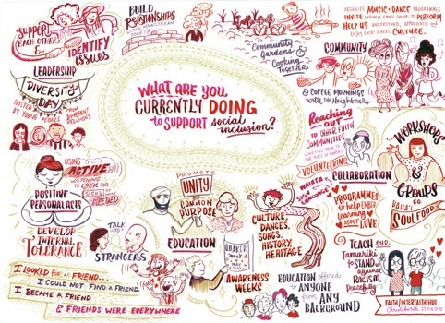

Faith communities and interfaith groups are also strong champions for social justice and change. Again, a range of activities are being undertaken, including consciousness raising about the Treaty of Waitangi; intercultural training; seminars on diversity; leading campaigns at a local level; advocating for former refugees and those experiencing financial and other hardships.

Education was also a strong focus for many faith communities and interfaith groups. Some spoke of current community outreach programmes
to educate people about the negative representation of some faith groups in the media, such as ‘I am a Muslim, Ask Me a Question.’
There have been approaches to media seeking a commitment to promote positive news stories
about faith communities, making documentaries about different faiths, and covering public statements on important faith issues.
Some interfaith groups have also reached out to businesses and the media to increase
intercultural and interfaith awareness. Examples of this included an ‘allies and advocates’ programme run for employees of Kiwibank;
and approaching retailers to encourage the acknowledgement of faith celebrations beyond Christmas and Easter, such as Eid and Diwali.

Many of these initiatives are being progressed by individual faith communities or interfaith groups, either locally or at times at a national level. In a supportive role, the National Interfaith Forum brings the network of Interfaith and Abrahamic Councils together every second year. The National Interfaith Network Aotearoa New Zealand (NIFNANZ) email network shares news and information. The Interfaith website (www.
interfaith.org.nz) has, since the 1990’s, published the list of Interfaith Councils and Abrahamic groups, with news of interfaith events and resources, together with the multifaith calendar for the month.

The Religious Diversity Centre as an agency engaged in research and educational programmes, offers workshops and professional development training, policy advice and opportunities for dialogue and collaboration
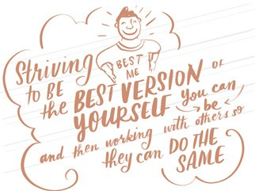
to build relationships among the diverse faith communities. Further opportunities exist in this area.

What more would we like to be doing?
Attendees were asked what more they would like to be doing, and how to increase current activities and find new opportunities to support social inclusion. The overarching message from all hui was the desire for greater dialogue and collaboration to normalise faith and ethnic/cultural diversity.

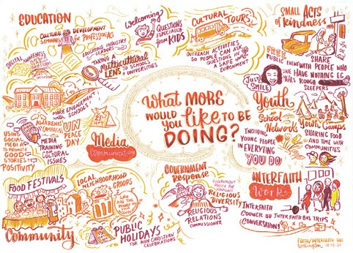

Perspectives on the role of Government
OEC heard that faith communities and interfaith groups want a closer connection with Government, and for Government to take a leading role in connecting them with secular society. This was seen as a way to counter
a perceived negative public narrative about religion. Some suggestions for Government to enable these connections included organising themed events or celebrations to promote religious and ethnic/cultural diversity, and a national ‘Religious Diversity Day’.

Attendees at all hui identified gaps in community awareness and information about interfaith activities already happening.

Some attendees thought that OEC could play a role in promoting activities already happening at a community level, to amplify their impact. Some suggestions for this included OEC holding a directory of faith communities and interfaith groups, creating social media groups, and hosting a multi-faith event calendar on the OEC website.

Attendees identified a clear role for OEC in promoting and supporting faith communities and interfaith groups, advocating for religious and ethnic/cultural diversity on state sector boards and committees, and finding more regular points of connection with faith communities and interfaith groups.

Community-led action
Although there was much discussion on the role of Government in supporting social inclusion, most participants recognised that they could not soley rely on Government to lead the change they want to see, and that they need to take action themselves through community-led initiatives.

Some ideas for community-led action focussed on neighbourhood-centered activities. These included making connections with neighbours through BBQs, coffee groups and neighbourhood discussions.

Similarly, some attendees wanted to enhance workplace initiatives to encourage intercultural exchanges through shared food and cultural days.

There was discussion about the importance of meetings such as the hui, and how to keep the momentum they generated going.

Attendees saw the value of in-depth dialogues around social inclusion on a regular basis. Some attendees told OEC that they intend to continue to connect with the people they met at the hui to see how they can work together. Others stated that they wanted to create fora for the exchange of cultures and ideas, which could include music and arts festivals.

Many attendees expressed an appetite for the establishment of a national faith/interfaith collective, with the capacity to respond to issues or events of significance to faith communities.
This network could provide cohesive leadership and decide collective programmes and actions to enhance social inclusion. Some saw this as being community-led, while other thought that support from Government would be needed to enable collaboration. Attendees thought OEC could support a process that fosters greater collaboration among faith communities.

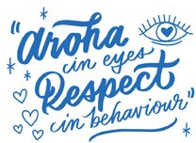

The role of education in promoting religious inclusion
Attendees told OEC that the education curriculum at all levels needs to better reflect the diversity of our student body by including lessons on different cultures and religions, minority groups and their histories, and multiculturalism. OEC heard that the teaching of Aotearoa New Zealand history and understanding of tikanga Māori also needs more emphasis.

OEC heard that schools need to take a leadership role in providing a learning environment that fosters inclusivity and promotes the value of diversity while also addressing discrimination, racism, xenophobia, and bullying.

Attendees felt that in order to understand diversity in a meaningful way, students need opportunities to be exposed to diverse
environments such as marae, places of worship, and other experiential learning environments.

There was a strong feeling across all hui that action is needed from educators at all levels when acts of discrimination are reported.

We heard that teachers should be trained extensively on handling different cultures and religions, and that specific funding should be allocated to provide professional development opportunities for teachers wishing to enhance their intercultural competency and religious literacy.

Many attendees at the hui strongly stated that cultural awareness and bias training should be regularly integrated into professional
development for teachers, public servants, health care professionals, and businesses in general.
This training could extend to what people should do when they witness acts of racism.

“Education is awareness. Let’s be open to people who want to
learn about our religions. We also need to make an effort to educate ourselves”.
Although the formal education system is seen as an important vehicle for educating our young people, many attendees said that wider society, faith communities, and Government also have a role to play.

Attendees suggested that workplace initiatives should be developed to provide employees professional development opportunities to enhance their intercultural competency and religious literacy.

A national programme for the business sector, in which businesses work together with Government agencies and among themselves to create initiatives promoting diversity and building a diverse workforce was seen as an important step.

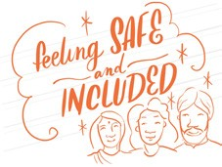
Alongside this, attendees commented that there is a need for more diversity training in the private sector, which provides time and training for individuals and groups in their workplaces to plan and promote intercultural and ethnic cultural events and information sessions.

The role of the media
Everyone expressed how the media has a responsibility to provide balanced news stories that allow for diverse perspectives, and raise awareness on issues such as racism, xenophobia and Islamophobia.

There was a strong feeling that Aotearoa New Zealand’s media outlets do not do enough to meet these responsibilities and that action is needed to ensure they are communicating a more balanced view of people of faith.

Many attendees expressed how important it is to see Aotearoa New Zealand’s diversity positively reflected in the media through the news, TV shows, documentaries and social media. Young people in particular are looking for role models in mainstream media that look like them, and reflect the country’s diversity.

Attendees were clear that there is a role for all community members to proactively engage with the media, and encourage them to highlight the many positive stories about people of faith.

Some attendees suggested creating a digital platform to share good news stories, successful ideas, projects, and initiatives so others can replicate them.

Some practical suggestions for harnessing social media included positive diversity and social inclusion videos and viral content, which have been successful in other countries.

Other attendees suggested media training programmes for faith communities to enable them to better portray themselves in the media, and to ensure communities have trained and designated spokespeople. ActionStation’s Tauiwi Tautoko initiative, which trains people how to respond to online discrimination, was given as an example of how to better equip diverse young people for online interactions.

Everyone agreed that by committing to include more diverse content, the media could play a key role in normalising diversity and supporting positive attitudes about different cultures and religions in wider Aotearoa New Zealand society.

Other themes raised and discussed
Attendees highlighted the importance of collective action and advocacy on issues which affect all communities. With ongoing public debate around freedom of speech versus hate speech, there is a desire for greater organisation among faith communities to have a collective push back against racism, Islamophobia, and xenophobia.
- Many people wanted closer connection with Māori. Māori have experienced mass murder, hatred and racism, and it is important for faith communities to connect more deeply with Māori to discuss what it means to be safe, included and embraced in Aotearoa New Zealand.

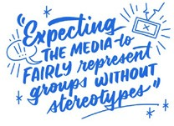
“The Treaty of Waitangi provides a great basis for cultural co- existence with respect. We need to work more closely with tangata whenua”.

  - There was much discussion, particularly in Christchurch and Dunedin, around the most appropriate way to remember those who lost their lives in the 15 March 2019 mosque attacks. Some Muslim attendees in Dunedin informed the hui that in Islamic culture, anniversaries are not comemmorated, and suggested that something in the name of those who lost their lives, which benefits the community in some significant way would be more appropriate.
Some attendees felt that moving the focus of 15 March from the terror attacks to peace and social inclusion would enable the day to be commemorated in a way which avoids further ‘othering’ the Muslim community, but allows non-Muslims to remember a day which will forever mar New Zealand history.

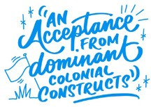

Opportunities from the hui
OEC has synthesised feedback from all four of the hui, and considered potential opportunities going forward. Below is a summary of the key themes and suggestions we heard, potential actions for OEC’s consideration, and some potential community activities to support these.

What we heard | Considerations for OEC’s work programmes | Community opportunities
Enhancing collaboration  There is much important work already happening in Aotearoa New Zealand, either within the more established interfaith groups or among  faith communities themselves. However, this work is limited and many attendees would like to see such activities being strengthened and expanded beyond  those usually involved.  Attendees would like a stronger relationship with Government. | OEC sees potential for greater collaboration and communication between faith communities.  OEC will consider the following for its work programme:  - Compile an ‘Aotearoa New Zealand Directory of Faith Communities and Interfaith Groups’, which faith communities and interfaith groups can voluntarily supply their details to and choose whether they wish those details to be available to the sector, wider Government, and the public.  - Further develop its connections with faith communities and interfaith groups within its work programme.  - Strengthen connections between regional faith communities and interfaith groups through its community engagement function.  - Continue to consider applications to the Ethnic Communities Development (ECDF) for activities which strengthen existing interfaith work. | OEC invites faith communities and interfaith groups to:  - Consider contributing details of your faith community  or interfaith group to the proposed directory.  - Connect with your regional OEC community engagement teams.  - Continue to apply to the Ethnic Communities Development Fund (ECDF) for funding for projects which enhance and expand connections between faith communities.

What we heard | OEC's proposed actions | Community opportunities
Religious and Cultural Diversity Week  Attendees would like:  - Opportunities for greater contact between and beyond religious communities.  - Increased opportunities for education about religious and cultural diversity in schools, workplaces and communities. | OEC will consider launching an annual Religious and Cultural Diversity Week that would commence on 16 May (marking the International Day of Living Together in Peace) and end  on 22 May (incorporating the World Day for Cultural Diversity for Dialogue and Development on 21 May) each year. This week would recognise the religious and cultural richness of diverse communities in Aotearoa New Zealand. To support activities during this week, OEC would look to:  - Work with the Ministry of Education, and any other relevant Government entities and interested parties from the NGO sector, to explore what resources and collateral can be developed and supplied to teachers and wider communities to promote teaching and activities during this week.  - Explore the possibility of the Minister for Ethnic Communities hosting a Parliamentary event during the week. | To make Religious and Cultural Diversity Week a success, we invite community groups, faith communities and interfaith groups, businesses, sports clubs, schools and local government bodies to join us.  Some examples of initiatives that may be undertaken include: hosting gatherings, talks, exhibitions, performances, competitions, and shared meals in local communities.

What we heard | OEC's proposed actions | Community opportunities
Education  Attendees see the education system as having a strong role in addressing stereotypes, racism, and discrimination. | Government is already undertaking a significant programme of reform, led by the Ministry of Education, to reshape Aotearoa New Zealand’s education system. This includes workforce development, response to Tomorrow’s School report, Early  Learning Strategy, revising the National Education and Learning Programme, and Reforming the Vocational Education System.  OEC will consider further work with the Ministry of Education to:  - Ensure that the issues that have been raised through these hui inform their work, and where possible support further dialogue with faith communities and interfaith groups.  - Explore what resources have been developed to grow awareness of religious and cultural diversity.  - Support the development of resources that increase awareness of religious and cultural diversity.  - Support the professional learning and development of those in the education sector to include greater awareness of religious and cultural diversity.  - Add to the OEC’s Intercultural Capability E-learning programme with training on religious diversity. | OEC invites faith communities and interfaith groups to:  - Connect with us on areas of specific interest so that we can broker conversations and engagement opportunities with the Ministry of Education.  - Assist in the development of content to add to OEC’s Intercultural Capability  E-Learning programme.

What we heard | OEC's proposed actions | Community opportunities
Supporting community work  Attendees talked about the importance of financial support from Government for grass roots community-led action | OEC has $4.2 million available per annum to fund community-led projects for ethnic communities through the ECDF. OEC would welcome proposals from faith communities and interfaith groups for projects that meet the overall ECDF criteria.  To promote and facilitate access to the ECDF, OEC will:  - Work alongside faith communities and interfaith groups to provide assistance and support with developing ECDF projects.  - Consider running workshops throughout the year that can be specifically tailored to faith  communities and interfaith groups  - Make timely, considered and robust decisions on ECDF requests.  - Work with other Government and philanthropic funders, such as the Department of Internal Affairs, Ministry of Social Development, and Philanthropy New Zealand to ensure that faith communities and interfaith groups can better access other funding sources. | OEC invites communities, faith and interfaith groups to:  - Continue to engage with their regional OEC community engagement teams in the Northern, Central and Southern regions, to discuss potential project ideas.  - Continue to grow internal capability and capacity to deliver projects to successful outcomes.  - Look for opportunities to work together on initiatives which will positively impact social inclusion and participation.

What we heard | OEC's proposed actions | Community opportunities
Leadership and civic participation  One of the common issues raised across the hui was the desire for equal access to representation in leadership positions.  Participants stressed that they wanted to see Aotearoa New Zealand’s diversity reflected in public figures, role models and leaders, and that they wanted more leadership opportunities for  their groups and communities. | The Government is clear that it wants state sector boards and committees to represent the diversity and demographic make-up of Aotearoa New Zealand, including ethnicity, gender, age and geographic location.  To support this, OEC maintains a database of suitably qualified people from within our ethnic communities, who want to be considered for appointment to state sector boards and committees. This database is used by Government agencies to identify possible nominees for state sector boards and committees. | OEC invites faith communities and interfaith groups to connect with the us to identify qualified candidates whose details can be added to the database, to increase the pool of candidates available to state sector boards and committees. .
Media  We all have a role to play in influencing how communities and faith groups are portrayed in the media. People want to see media coverage normalising diversity by including messages of inclusivity. | OEC will consider the following:  - Compile a contact list for mainstream media interested in covering news from our ethnic communities, and a list of ethnic community media, that can be hosted on our website.  - Investigate what resources, including media training are available to support faith communities to tell their stories and connect faith communities with resources, training and funding.  - Work more actively with the Human Rights Commission to support  and promote social inclusion and counter racism, discrimination and religious intolerance. | OEC invites faith communities and interfaith groups to:  - Continue to disseminate ‘good news stories’ to counter existing negative stereotypes in the media.  - Look for opportunities to educate the wider community, local media and other important influencers on the importance of understanding the value of religious and ethnic/cultural diversity.

Appendix A
Dunedin
2 February 2020

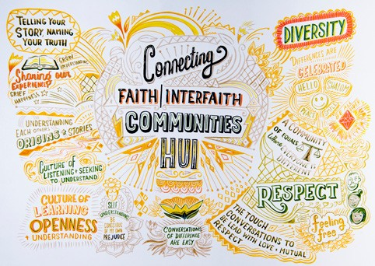

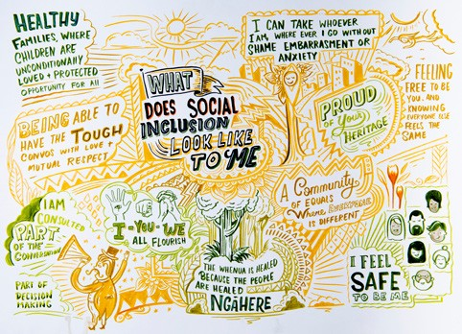
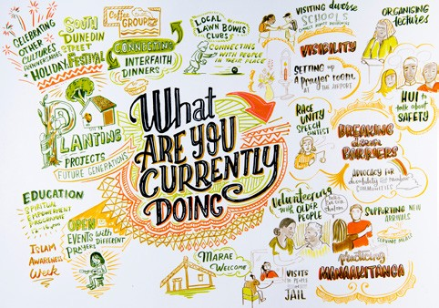

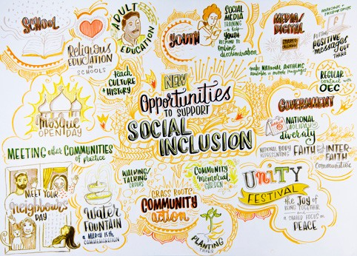

Auckland
16 February 2020

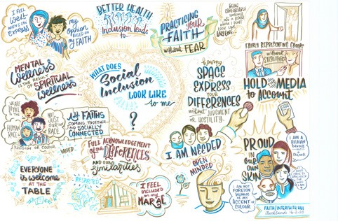

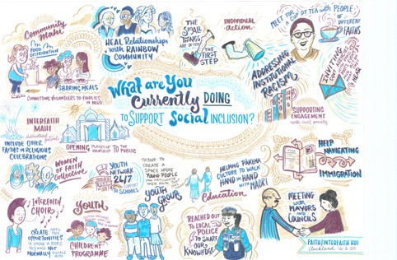

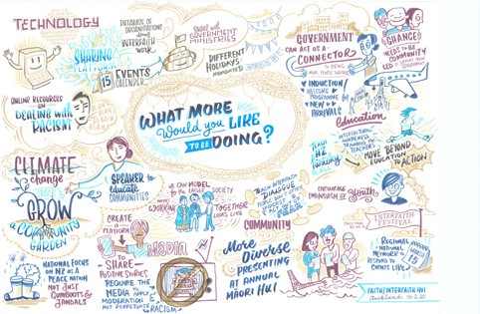

Christchurch
23 February 2020

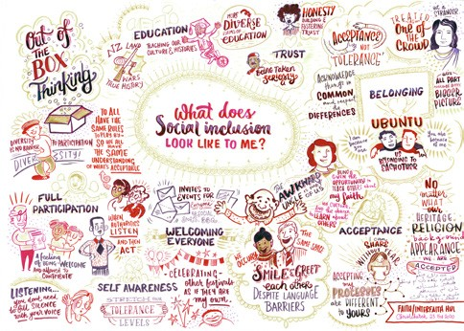

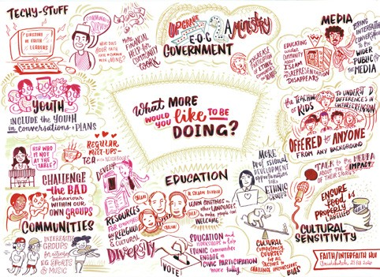

Wellington
1 March 2020

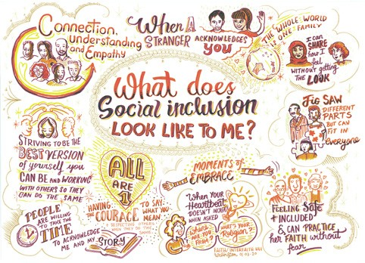

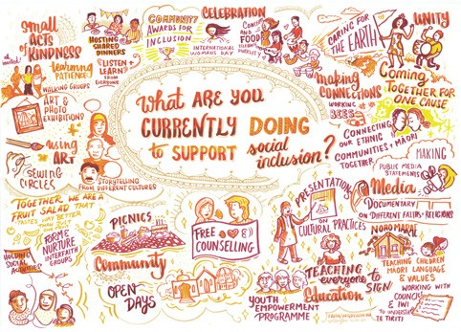

Appendix B

27 November 2019
Connecting Faith/Interfaith Communities Hui 2020 FAQs

Where will the hui be held?
The hui will take place in Dunedin, Auckland, Christchurch and Wellington.

When will the hui be held?
Sunday 2 February  – Dunedin | Including Southland and Otago attendees]
Sunday 16 February  – Auckland | Including Waikato, Bay of Plenty and Northland attendees
Sunday 23 February  – Christchurch | Including Marlborough and West Coast attendees
Sunday 1 March  – Wellington | Including Taranaki, Manawatu, Horowhenua, and Hawkes Bay attendees

Where will the hui be held?
We are still confirming the venues and hope to be able to share this information soon. We will make sure that all the venue details are included in the invitations.

How long will the hui run for?
We are still confirming exact timing as we agree venues, but all hui will take place between 12 noon and 5pm and will run for 4 hours.

What is the purpose of the hui?
Following the events of 15 March 2019, the Prime Minister met with faith leaders in June to discuss how we could build greater interfaith collaboration with each other and within New

Zealand, and what could be achieved by an interfaith dialogue with government through a series of regional hui.

The purpose of the regional hui is to discuss, identify and agree on specific actions to promote greater social inclusion and wellbeing, and to counter racism, discrimination and religious intolerance.

We see these hui as a chance for people to make broader connections outside of the communities that they represent and/or have traditionally connected with, and identify community
led action that encourages and facilitates understanding and respect, tackles harms to inclusion, and grows awareness of the benefits of diversity.

We are refining the approach to the hui, but discussion will broadly focus on
- Sharing what attendees may already be doing to support social inclusion and wellbeing
- Identify further actions that could be jointly worked on (national body for interfaith issues, social justice, wellbeing, and or awareness/ education projects) and those interested in working/leading these projects
- What role government or others might have in supporting this work.
The Office of Ethnic Communities will collate actions coming out of each hui and send these to participants, connect interested people, and provide information and initial coordination/ secretariat support in the interim.

How are the hui being designed?
We have been working with a Reference Group, comprised of those with a lot of experience
in the connecting faiths space; and leaders of Aotearoa’s key religions to design the hui.

We also have two skilled and experienced facilitators onboard. They are refining the approach to the hui at the moment, including how the day will be focussed. And we have discussed this with other interested parties – including Interfaith Councils.

Will there be a discussion theme? Yes, we will send this out along with the invitations.
We are working with the facilitators on how we structure the hui and focus our discussions. We will provide this information ahead of the hui to give attendees time to reflect on it before they attend.

How many people will attend the hui? There will be approximately 120 attendees at each hui, depending on venue capacity. The
Auckland hui will be held at a larger venue, as
it also incorporates large faith communities in Hamilton and the Bay of Plenty.

Who should attend?
We are seeking nominations of attendees from faith and interfaith groups.

How many people from my group should I nominate?
Each Interfaith Council will be invited to nominate up to 12 attendees for each of the hui, to reflect the diversity of their membership.
Each Faith organisation will be invited to nominate up to five representatives for each of the hui.

Who should I nominate?
We are seeking as rich a diversity in faith tradition, gender and age as possible. We are also very keen to expand the reach of this mahi beyond those already involved. To that end, the reference group encourages you to also include people who may not have a lot of experience in connecting faiths but have a lot of energy and can get things done.

When should I send you my nominated attendees list by?
Please send your nominations to us by Monday 9 December please. If this will not be possible for your group please let us know and we will try and find a date that works – please note though that we need to send invitations out by mid December.

How will invitations be sent out/managed? OEC will send out invitations to manage travel, catering, and any specific attendee requirements
such as mobility assistance.

Please send the names and contact emails for your nominated attendees to ethnic.
communities@dia.govt.nz on the form provided.

Attendees will then be sent a formal invitation which is not transferable. However, if a nominee is unable to attend they are welcome to contact us to propose an alternate name.

I don’t live in any of the hui locations, will there be transportation for me to attend?
Yes, once we receive the list of nominated attendees, we will determine the best way to help people get there – for example same day seat only flights, or ground transport. Those who wish to drive will be reimbursed for their fuel costs. We encourage people to reduce the carbon footprint of the hui by car pooling where possible.

I have further questions, who do I contact? Email us at ethnic.communities@dia.govt.nz and the most appropriate person to answer your
query will be in touch.

Appendix C

Hui | No. attended | Organisations attended | Organisations unable to attend
Auckland | 89 | Ahmadiyya Muslim Jama’at NZ Inc | Belong Aotearoa
 |  | Anglican Church | Chinmaya Mission
 |  | Auckland Council | Greenlane Christian Centre
 |  | Auckland Interfaith Council | Hamilton Council
 |  | Auckland Sikh Society | Hamilton Multicultural Services  Trust
 |  | Bahá’í Community | Hazara Afghan Association  Incorporated
 |  | Baptist Churches of New Zealand | Just Community
 |  | Baptist Union of NZ | Ministry of Social Development
 |  | Bharatiya Mandir | Salvation Army
 |  | Buddhist Council | First Give
 |  | Catholic Church | Thirumurugan Alayam
Federation of Islamic Associations of
New Zealand
 |  | Hamilton Balaji Temple
 |  | Hindu Council of New Zealand
 |  | Hindu Youth Council
 |  | Islamic Council of New Zealand
 |  | Islamic Women’s Council
 |  | Methodist Church New Zealand
New Zealand Catholic Bishops’
Committee for Interfaith Relations
 |  | New Zealand Christian Network
New Zealand Council of Christian Social
Services
 |  | Human Rights Commission
 |  | New Zealand Jewish Council
 |  | New Zealand Police
Presbyterian Church of Aotearoa New
Zealand
 |  | Rātana Church
 |  | Religious Diversity Centre
 |  | Seventh-Day Adventist Church
 |  | Sikhism
 |  | Tauranga Moana Interfaith Council
Te Hāhi Tūhauwiri, the Religious Society
of Friends
The Church of Jesus Christ of Latter Day
Saints
 |  | TIFG
 |  | Waikato Interfaith Council
 |  | Wesleyan Methodist Church
 |  | Whangarei Interfaith Council

Hui | No. attended | Organisations attended | Organisations unable to attend
Christchurch | 63 | Anglican Diocese of Christchurch | Christchurch Chinese Church
 |  | Bahá’í Community | Linwood Mousque
 |  | Buddhist Council | Muslim Association of Canterbury
 |  | Canterbury Interfaith Council | Nelson Interfaith Council
 |  | Catholic Church | Rātana Church
 |  | Christchurch City Council | South West Baptist Church
 |  | Federation of Islamic Associations of New Zealand | Timaru Ministers Association
 |  | Hindu Council of New Zealand
 |  | Human Rights Commission
 |  | Islamic Women’s Council
 |  | Lincoln University
 |  | Methodist Church New Zealand
 |  | Nelson Whakatau Muslim Association
New Zealand Catholic Bishops’
Committee for Interfaith Relations
New Zealand Council of Christian Social
Services
 |  | New Zealand Jewish Council
 |  | New Zealand Police
 |  | Refugee Resettlement
 |  | Religious Diversity Centre
 |  | Revathi Cultural Association
 |  | Seventh-Day adventist
 |  | Shri Ganesh Temple Christchurch
 |  | South West Baptist Church
Te Hāhi Tūhauwiri, the Religious Society
of Friends
The Church of Jesus Christ of Latter Day
Saints
 |  | United Afghan Association of Canterbury
 |  | Wesleyan Methodist Church

Hui | No. attended | Organisations attended | Organisations unable to attend
Dunedin | 48 | Anglican Church in Aotearoa | Caversham Baptist Church
 |  | Arai Te Uru Whare Hauora | Islamic Women’s Council
 |  | Bahá’í Community | Rātana Church
 |  | Baptist Union of New Zealand | Seventh-Day adventist
 |  | Buddhist Council
 |  | Catholic Church
 |  | Dunedin Abrahamic Interfaith Group
 |  | Dunedin City Council
 |  | Dunedin Interfaith Council
 |  | Dunedin Hindu Temple Society
 |  | Hare Krishna Cultural Centre (ISKCON)
 |  | Methodist Church New Zealand
Muslim University Students Association
(MUSA)
New Zealand Council of Christian Social
Services
 |  | New Zealand Jewish Council
 |  | New Zealand Police
New Zealand Catholic Bishops’
Committee for Interfaith Relations
 |  | Otago Muslim Assocation (OMA)
Presbyterian Church of Aotearoa New
Zealand
 |  | Religious Diversity Centre
The Church of Jesus Christ of Latter Day
Saints
 |  | UAAC

Hui | No. attended | Organisations attended | Organisations unable to attend
Wellington | 96 | Ahmadiyya Muslim Jamaat NZ Inc | Amma New Zealand
 |  | Anglican Church - Hui Amorangi ki te  Upoko o te Ika | BAPS Swami Narayan Temple
 |  | Anglican Diocese of Wellington | Caritas NZ
 |  | Bahá’í Community
 |  | Baptist Churches of New Zealand | Chin Agape Christian Church
 |  | Buddhist Council  Catholic Church | Federation of Islamic Associations of New Zealand
 |  | Coexistence | Hare Krishna Temple (ISKCON)
 |  | EKTA New Zealand | Rātana Church
 |  | Hawkes Bay Interfaith Council | Wellington City Council
 |  | Hindu Council Wellington Chapter
 |  | Hindu Youth Council
 |  | Human Rights Commission
 |  | Islamic Women’s Council of New Zealand
 |  | Kapiti Interfaith Group
 |  | Methodist Church New Zealand
 |  | Namasankeerthanam Group
 |  | New Zealand Hindu Association
New Zealand Catholic Bishops’
Committee for Interfaith Relations
New Zealand Council of Christian Social
Services
 |  | New Zealand Jewish Council
 |  | Palmerston North Interfaith Council
Presbyterian Church of Aotearoa New
Zealand
 |  | Quakers
 |  | Religious Diversity Centre
 |  | Salvation Army
 |  | SDP Seva Trust
 |  | Seventh-day Adventist Church
The Church of Jesus Christ of Latter Day
Saints
 |  | UAAC
 |  | Wellington Abrahamic Council
 |  | Wellington Indian Association
 |  | Wellington Interfaith Council

Appendix D

Feedback on first version of the report

Theme | Submission | Action
Overall report | - Report is comprehensive and covers the issues heard at the workshops attended.  - Report is a substantial document covering a wide range of important issues.  - Report admirably covers the main areas of concern and interest: education, local community involvement, the valuable link with government policy, media issues, and the distinctive role of faith communities in forging a social consensus.  - Great work on this report, you and the team should feel very satisfied with what you have been able  to accomplish. Thematic analysis of 4 hui’s into something that looks as coherent as the final report is  simply exceptional. | Noted.
Definition of Interfaith | - Interfaith societies and councils are not “communities” either distinct or separate from faith communities but are a means by which faith communities communicate and maintain friendship links. The conflation and confusion of “faith and interfaith communities” occurs throughout the report, in themes 1, 3, and 5.  - According to Oxford Dictionary “interfaith” means “relating to or involving different religions or members of different religions”. I find it is rather inappropriate to use “faith/interfaith” as if interfaith are another faith, but that is used throughout this draft report. I cannot say for other regions but I know for certain that [name of organisation] has been working already on many aspects of what you are proposing in your draft report, but from well before the March 15th incident. | Report adjusted– in particular, a clearer distinction has been drawn between “faith communities” and “interfaith groups”.
Conflation of ethnic and faith communities | - OEC has lumped together ethnic communities and faiths. | Report adjusted as appropriate to clarify the distinction between faith and ethnicity/ culture.

Theme | Submission | Action
Education | - Concern that theme 2 blurs the repeated call over many years by religious leaders, for religious literacy and education about religions, into an amorphous and vague theme about ethnic cultural diversity. Refers specifically to Statement 6 of National Statement on Religious Diversity (2019) i.e. schools should teach  an understanding of different religious and spiritual traditions in a manner that reflects the diversity of their national and local community. | Revisited hui notes and agree – 1st draft did not capture discussions around religious education in schools accurately. Final report adjusted accordingly.
Religious Intolerance | - Emphasis on diversity can dilute the discussion of violence, hatred and divisiveness. In bringing diverse faith communities together for discussion it is natural and useful, particularly post-attack, that topics of interest include how to combat religious intolerance. Conversations on antisemitism, islamophobia,  and other matters of hardened attack-mindsets are important topics for us. The draft report does not address these directly. What it says about its purpose as a report is that it is a next step from the conversations with the Muslim communities, and  that it recounts a “canvassing (of) broader views on how to strengthen social inclusion and acceptance of diversity”. In other words, despite the call being to faith and interfaith, the hui and the report are structured to only tackle religious intolerance as a co-factor or “third on the list” after racism and discrimination in general. This must be why for the most part the report does not recount people’s struggles with expressions of hatred based on faith or divisive speech about faith, within the reasons for education changes but focuses instead on the normalising of “diversity”.  - No mention of real experiences of Islamophobia, antisemitism, hate speech. It must have been discussed but is not reflected in the report. | Revisited hui notes to ensure the report accurately reflects  discussions at the hui. It is acknowledged that Islamophobia, antisemitism, hate speech and associated issues were all discussed, but more  in the context of setting the scene for current work and the  opportunities that have been identified.

Theme | Submission | Action
National Collective | - Intrigued by the suggestion of some form of national collective, but obvious difficulty being to find a way of constituting it which avoids gathering together formal representatives or academics who are not really in touch with their core communities. As a religious historian, is highly conscious that often faith communities have in the past created barriers between people and have played a highly negative role. The involvement of government may offer a  welcome corrective, perhaps, to this danger. One way forward might be to expect the representatives of any faith community to gain the support of those from a different faith community.  - Fully agree with the potential noted by OEC in the development of a national collective but feels that the statement - “If there is a desire to do this, it must be driven and owned by the faith/interfaith sector not by Government” is questionable as she believes that a body such as OEC can and should help drive the formation of such a collective. The reasoning  for this position is the recognition that whilst the interfaith sector provides a very useful service in enhancing social cohesion, as a ‘sector’ it has inherent weaknesses in that currently it has no full-time staff, no office, no budget, and hence no one to ‘drive’ and organise on a national level. For a national voice/body to emerge some logistical support will be essential.  Specific recommendations proposed are:  - Local OEC staff members be assigned as a liaison person with each city/town where an interfaith group currently exists to get to know the leadership of their respective interfaith group, understand their programmes and aspirations, and provide on the ground support in areas needed; | The idea of a national collective was mentioned at the hui. The text of the report now details more clearly what was said.

Theme | Submission | Action
- These OEC interfaith ‘specialists’ would form a national focus group under a senior OEC manager. Organised by OEC, regular Zoom meetings, perhaps twice a year, could be initiated among all the Interfaith group leaders and OEC selected staff, so that issues of national concern can be raised, best practice can be shared, and the collective voice
of interfaith stakeholders can be heard; and to get some ideas of how interfaith work is done in Scotland, a country that has similarities to NZ in
terms of population and demographics, a report by the Director of Interfaith Scotland explaining how their interfaith sector is functioning and supported was attached as an example of good models for how government can support the grassroots
level (report was also shared with Priyanca Radhakrishnan and Sean Lim from OEC at the Auckland hui).
- Idea of a “national collective” (theme 5, page 12 of the report) is a surprise and was not mentioned at the hui, This may be easier for government
and possible for larger faith communities to do but for smaller communities such as [name of organisation] this would be another demand on already limited volunteer resource and concern over whether they will be able to contribute to this, or recognition that this would only be in a very limited way. The report floats the notion
of a “national collective” for faith and interfaith groups and says this could serve as a “conduit” to engage with government. We must report to you that our attendees are in accord that this suggestion has no basis in anything universally discussed at the meeting. We see a range of issues with such a proposition, including that we do not find it appropriate for the faith sector to carry the load of creating such an entity. For the Government to engage it should deal with the
national organisations or intra-faith councils which already exist for many major faiths but should not exclude smaller faiths in the process. For authentic engagement, the Government must retain suitably
skilled persons to be facing the diversity directly.

Theme | Submission | Action
Diversity Week | - Think it is marvellous that 15 March will begin Religious and Cultural Diversity Week, and notes that it is a powerful way to remember those lost, and to affirm what we wish this country to become - a multi- cultural nation on a bi-cultural foundation which values, appreciates and celebrates religious diversity as a strength.  - The timing of the “diversity week” is also a matter of concern to us. It is our understanding that the majority of affected families do not want an annual event marking 15 March. They only agreed for once only simply because they thought the people asking needed it. There is a call from the affected communities for how to honour the departed by practicing care for humanity within our lifestyles. However, memorialising “those who lost their lives” by celebrating diversity (“talks, exhibitions, performances, competitions, dinners ...) on the anniversary of the attacks is not appropriate.  • | The language of ‘celebration’ has been removed.  OEC recognises that finding the right balance is difficult. We have therefore changed the proposed date of a Religious and Cultural Diversity Week to May so it is not associated with 15 March.
Role for Faith Communities | - Key role for faith communities in broadening people’s horizons and helping society to get beyond well- meaning but superficial reactions – e.g. the way in which the spiritual dimension of the Treaty of Waitangi is being increasingly recognised; political and legal initiatives in other areas by deeper reflection on the values we wish to see enshrined in them; to utilise religious ‘tools’ such as ceremonies and rituals to  ease people out of their encrusted ways; to think about the ‘other’- e.g. on the marae, big words such as partnership, reconciliation can be unpacked where space is given for collective celebration but also  lamentation. | Noted.

Theme | Submission | Action
Suggestions for further thought/ work | - Set up an Interfaith Communities of Practice network around the country and resource appropriately. Support what is already in place and working through local networks/interfaith councils,  including appropriately resourcing these. Move from “celebration” to “dialogue” discussion. Build cultural and interfaith capacity and the capability of OEC to understand the interfaith space and connect with key people/organisations. Set up a ring fenced contestable interfaith fund within ECDF for a minimum of 3 years to encourage community based, community driven and impact outcome focussed initiatives. Listen beyond the noisy and prominent voices. Develop an Interfaith Youth Leadership Training Programme Partner with  private and community sector. | Rather than ringfence any funds within  the ECDF, OEC will continue to consider funding requests to the ECDF under the  current criteria for local networks/Interfaith Councils to expand the work they already do; and for partnerships between private and community sectors.
Issues with the second part of the report | - The theme introduced at the start of the report (page 4) “To connect and collaborate better with Government” was not discussed at the hui in the way we think needed - i.e. to collaborate around Government learning to do a better job of resourcing interfaith and listening to faith communities and  interfaith organisations. Despite the above factors the report presumes to recommend measures to give our sector “direction and voice”.  - Statement made that “everyone” is saying that this was a government tick box exercise, and that there are concerns about the confidence of the legitimacy of any recommendations “when 80% of people in the room had no experience of interfaith and no authority to represent their faith communities”. Also note that “with our communities silence is not acceptance” and that “there are a variety of other issues that might be worked into the first section however everyone is still very upset with such a disrespectful short time for feedback when everyone is volunteers”. On a personal level, subject to further group discussion, a plan B might be to remove completely the “Way forward” as this is probably the most contentious issue as there was no authority, by anyone, at any hui to make any  such recommendations. | This theme was discussed at the hui and the final report has been adjusted accordingly to explore it in more detail.  There has been some adjustment of language, and the report no longer recommends measures.  Noted. The intention of the hui was to bring people who have not traditionally been involved in interfaith work together with those who have. ‘The way forward’ from the original report has been reframed and now presents potential opportunities.

Theme | Submission | Action
 | - About our “voice”, we have always had our voice however the Government does not always want to hear us. Unless something significant happens -- in this case March 15th. Does your office really want to hear and understand us at this time? From your draft report it does not seem to be the case because there are big proposals we did not voice at the hui. I write from  the committee of [name of organisation]. In [name of place] we have working interfaith links with the  communities affected by the events of 15 March 2019, each of the main faith streams, and many minority faith communities. We have been active since 2007 with regular meetings at different faith group centres. We hosted the National Interfaith Forum in February 2010. We did not attend the hui to be spectated upon and then written up as a subset of the (albeit serious)  concerns over racial and ethnic prejudice. | The original reference to ‘voice’ has been removed from the report, and ‘the way forward’ from the original report has  b reframed and now presents potential opportunities  FAQs for the hui have been included as an appendix to the second version of the report, to make the purpose of the hui clearer.
Skilled Migrants and Former Refugees | - Notes that it is important to distinguish between the needs of skilled migrants and the needs of former refugees. Some time was spent by the hui group discussing this item and when taken back for wider discussion in the [name of group], Muslim, Indian and Sikh communities resonated strongly with this distinction. Both groups have issues associated with  “belonging”, but they are very different. Has asked that  this be noted for wider consideration. | Noted.
Black Lives Matter | - Additional upsurge of concern in the Black Lives Matter movement, which highlights the interconnection of  so many factors: historical heritage; inequality and  poverty - both cultural and financial; deep-rooted prejudices, and also something of a generation clash. | Noted.
Religious Diversity Centre | - Promotion of the work of the Religious Diversity Centre, noting that they were also engaged nationally and regionally in workshops on religious diversity and anti-discrimination, before 15 March 2019. | Noted.
Information about community activities | - [name of group] met on 10 June to begin organising interfaith programmes for July, August, September, October and November. Notes that everything done by the group is to promote social cohesion between the seven faith communities engaged with interfaith  dialogue in [name of place]. On 11 June, the group also held an interfaith vigil to overcome racism in response to the killing of George Floyd and the institutional  racism and violence that this represents. | Noted.

Theme | Submission | Action
Inspiration | - Referred to Caroline Bridgland’s quote at the hui in her capacity as OEC’s Acting Director - “Observation and Wero for 2020, we will see the best and the worse, my Challenge is what can I do today to make tomorrow better?” – and noted that this has become an inspiring mantra for many. | Noted.
History of Interfaith Movement in NZ | - Missing from the report- Heritage of the interfaith movement in NZ to date over the past 35+ years, including work done by central government, local government, faith and community initiatives, National Interfaith Fora, Asia Pacific Regional Interfaith Dialogues, and local interfaith councils. | The heritage of the interfaith movement in NZ has now been acknowledged in the report.
Strategy | - What is Government agencies’ strategy to move forward after this report? | The second part of the report (pages 17-21) has been re-formatted to make this clearer.
Interfaith nominations on State Sector Boards | - Would like to nominate [name] and [name] to be considered for state boards as spokespeople for religious diversity and interfaith relations | OEC will follow up with those nominated to gauge their interest.
Request for further engagement | - We remain open for dialogue and will be keen to meet you in person in the future to confer, should there be an undertaking from the Government for OEC to have discussions about the workings of interfaith with the regional organisations. “Requests we wish to give “voice” to now. We request that the draft report be edited to take into the account the issues we have raised. We also urge that there be a commitment to talk with interfaith groups around the country about an authentic consultation with the faith sector and the interfaith groups. | The revised report has been edited to consider the issues raised. Follow up to be initiated through the relevant regional OEC Community Engagement team.
Request for further engagement | - If you are really interested in building a mutual understanding between the Government and our communities I would like to invite you to come and see for yourself how we practice our faith and celebrate our culture and tradition while making New Zealand our home -- rather than put us in a room with people, many of whom we already knew, to talk to each other within a specific range of topic your office wants to focus on. | Follow up to be initiated through relevant regional OEC Community Engagement teams.

Theme | Submission | Action
Information request | - Request for information:  - None of the [name] community were invited.  - Main concern was how the hui was arranged and how people were invited.  - Were people invited to all 4 hui?  - Did OEC discuss with the Reference Group who should be invited?  - Why were some people rejected?  - Was not aware of hui or transport to get there.  - Would like to see a list of the organisations that attended the hui.  - Did the Reference Group recommend or suggest other groups? | Further detail provided re: process; FAQs provided, list of organisations added as an appendix.
Process | - Request for more time (at least one month) to allow for genuine consultation from within the interfaith sector  – i.e. to communicate with fellow volunteers, digest the report, and formulate responses. Notation that that around the country the interfaith sector is wholly consistent of volunteers – i.e. no full-time or paid staff, no offices, and volunteers have to fit in interfaith work around other responsibilities.  - I must say that I am also a bit dismayed at the lack of time the OEC has given us for consultation, having only just received the report a week ago. I am unable to submit my own comments in such a short time frame, so am resorting to supporting their submissions on the draft report. This is a shame as the various Interfaith Councils throughout the country would have quite a lot to say about this report and I feel that the OEC has not allowed sufficient time for proper consultation.  - The [name of organisation] wishes to send you its views on the Draft Report but is unable to meet the deadline of today, which we think is asking too much from a voluntary group which wants to incorporate the opinions of all its representatives, NZ-wide, who  attended the hui. | Further detail provided re: process; FAQs provided, list of organisations added as an appendix.  Production of report unfortunately delayed because of the impact on the resources of the Office because of Covid-19.  While no formal extension of time for feedback was given, follow up conversations occurred with some submitters.

Theme | Submission | Action
- We offer our feedback and some corrections on the report, while letting you know that the period of time given to us to respond to the draft is not enough for us to reply in the depth that is needed to convey our analysis of all the thematic suggestions in the report and their potential effects, nor to confer widely across our diverse membership.
- While there was no space at the hui for community announcements in a formal sense, our people at the hui spoke of what we already do as an organisation and invited faith communities represented at the hui to continue in that with us. We can accept that our descriptions of our activities are included in page 7 of the report. Regrettably the hui was not engagement with government nor consultation. The FAQ with the invitation to the “hui” / meetings gave points that discussion would focus on, and the third point was the discussion on - What role the government or others might have in supporting this work. So, we attended anticipating that the Office would have a process
for that. However, the facilitator, Dr Farry, firmly and repeatedly directed us to only discuss actions that could be worked upon between invitees and to keep away from matters of governmental policy, i.e. not to be engaging with the host.
The FAQ also requested that we nominate “people who may not have a lot of experience in connecting faiths” for the reason given to us on inquiring, that they might be younger and more energetic, perhaps we thought, as “diversity mascots” rather than for knowledge and skill at interfaith dialogue and ability to contribute to a “what’s next” dialogue.

Theme | Submission | Action
- As a migrant for whom English isn’t first language, who attended the “hui” in [place name], I noticed that many attending would be in the same situation as I am. To have received a-15-pages report in non- colloquial English means we have to take many days to fully understand what is being said. Also now many migrants have had extra time consuming stresses related to retaining some income after-lockdown. If the report had come during the lockdown that would have helped. We were promised this draft report back in April which was not long after the “hui” therefore that would be a reasonable time. However April came and went without words of advice to us that there was postponement of reviewing this draft. Perhaps you were hoping that we would go along with what you said in the draft since as the “hui” happened four months ago our memories have faded.
- Can you please give us another two weeks to fully formulate the [name] response?
- People agreed to come to an engagement and not a consolation.
- No respectful cultural safety briefings were provided as part of the hui programme.
- No feedback/evaluation forms so any claims of success is anecdotal.
- No discussions or scoping of the obstacles to interfaith dialogue, including interfaith tensions.
Formatting | - Formatting - would be helpful to see action points highlighted in some way. | Final section of the report (pages 17-21) has been edited accordingly.

Theme | Submission | Action
Acknowledgements | - Hui were inclusive in presence of people/participants but not inclusive in discussion of ideas.  - Appreciation of the huge amount of diligent work and creative analysis in the report. Complimentary of report format, and ease of reading and  comprehension. Has captured majority of discussion.  - Clarity of sections focus attention is good.  - We wish to offer acknowledgement that there is considerable good material in the draft report, derived from accurately observing and summarising the dialogues of people of faith within the discussion themes given.  - We welcome the broad acknowledgement that education needs to adapt to teach a better understanding of the people that live in this country, their religions, ethnicity and cultural practices. The relevance of the attitudes of the media and the portrayals of our faiths and people was certainly also a topic that came up at the hui in various ways.  - Recognises that the work that OEC is doing to promote social cohesion in Aotearoa New Zealand represents  a passionate commitment to overcome racism in this country – noted also that this intention was evident in the draft report.  - Acknowledgement of the work done on the report and OEC’s efforts to keep this “Hikoi o Manaakitangata healthy and growing”. | Noted. No changes made.

Feedback from on second version of the report

Theme | Submission | Action
Inaccuracy in Appendix C | One quick thing we would like to fix is the Appendix with Wellington attendance information. You may have received an apology from someone, perhaps [name] however, [name] – who is  a long time member of the [name of organisation] – was definitely present on the [name or organisation] behalf, and reported back via our committee. One of our key jobs, as appointees to the committee, is to represent the [name of organisation] at such events.  Would it be possible to add the [name of organisation] to the main block and remove it from the ‘unable to attend’ column, please. | Name moved to correct place
Re-writes of text to enhance accuracy | - When I gave the second draft to my husband to look at, he pointed out how people in another country would be impressed with what is going on in New Zealand!!  And this gave me confidence to offer you a re-write of  the last paragraph on page  11. It seems to me that the report needs to include these important institutions or organisations that are not interfaith councils, but  support or perform a service for the interfaith councils and  faith communities. | Noted

Theme | Submission | Action
vThe items mentioned in the original paragraph - open days for places of worship, newsletters, and peace walks
- need to be included in the earlier section on activities undertaken by Interfaith Councils.
- The sentence on page 5 “both a secular and
religious society” would be more accurate as “Aotearoa New Zealand where there are people who identify with faith communities and those who do not”.
- On page 18, “Opportunities to engage with secular society” again reifies and misuses “secular” and would be better rewritten as “Opportunities for greater contact between and beyond religious communities”.
- Page 14, “intercultural competency” doesn’t necessarily include “religious literacy”, between simply as “intercultural competency
and religious literacy”.

Theme | Submission | Action
- Page 21, “ethnic” is used to implicitly include “religious and cultural”, it would be more salient to deliberately disaggregate ethnic from religious, so “religious
and ethnic communities”; “from our religious and ethnic communities”;
and “list of ethnic and religious media”. This is partly addressed by the notes about board and
committee membership.

Theme | Submission | Action
Opportunities’ section | - I appreciate why “recommendations” has become “opportunities” but it will be vital to point to a way forward that will allow the national network/ group to be explicitly and sufficiently discussed by the faith communities and interfaith groups, discretely and in combination over the next months.  - The Report is greatly improved by the responses to feedback, and there are exciting “opportunities” form education, professional development, resource development, and so on.  - The five areas identified under “The opportunities we heard” are all very important. We believe  if the suggestions made in this section are fully carried out, huge steps will be taken towards  greater social inclusiveness and countering racism, discrimination, and religious intolerance. Their implementation certainly requires concerted efforts by the faith/interfaith communities and the Government working  together. | Noted.

Theme | Submission | Action
Overall report | - We appreciate the Office’s efforts to talk to Muslim communities and hold Huis with other faith and interfaith communities  to survey their views on important issues they face in New Zealand society.  - We believe the views expressed in Huis have been presented in a very concise and clear manner.  - The views highlighted in “What does social inclusion mean?” are very pertinent, and we are pleased that the Office has taken note of them. | Noted.

Theme | Submission | Action
National collective | - I did want to put something in writing beforehand because I am very uncomfortable with “the importance of a national interfaith voice” to work with government because I don’t know what it means. In my response to draft one, we were asked to nominate people to sit on boards and I nominated [names]. I am very certain that [name] does not see the [name or organisation] as being representative of the 13 diverse Interfaith Councils in New Zealand. And I’m sure the [name of community] does not see itself as representative of a national interfaith voice.  The [name of organisation] has its own mission and  is doing this work very well. It is very involved in giving workshops on religious diversity and  antidiscrimination to produce citizens who appreciate the religious and ethnic diversity  of our country. | National collective opportunity changed to ‘enhancing collaboration’ on page 17 of final report.

Theme | Submission | Action
[name] has been involved in interfaith dialogue for at least 30 years, and I’m sure that he would say that the
strength of interfaith councils and the work they are able
to do in the community is precisely because they have autonomy at the local level and leadership is at the local level. There could not
possibly be national interfaith voice because interfaith councils are comprised of faith communities whose theological beliefs are different. We can, without a doubt, affirm the fundamental unity of the human family, and our commitment to
work together to counter the horrific effects of discrimination and racism, despite our theological differences. Indeed all our programmes are about
building relationships of trust, friendship and love as we work together to promote social inclusion through interfaith harmony, and build together
a society based on justice and solidarity with the victims of oppression.
So, what I heard over and over again is that the best thing that government can do for people engaged at interfaith dialogue at the local level is
to listen to what we are doing and support us financially to
achieve these important goals.

Theme | Submission | Action
- Thank you for the additional information you have provided before the third Reference Group meeting on Monday 20 July. Information provided included the table of feedback received by the
OEC on the first draft of the report, and the names of those invited to the Group.
As you know we provided short written feedback on the first draft, and see from the feedback table that our three key concerns were also raised by others. We are satisfied that two of our concerns have been addressed in the revised report.

We remain concerned about the proposed national collective.

The claim on page 17 of the revised report that “Attendees would like a centralised, national interfaith hub or collective to support interfaith activities” is, in our view, an exaggeration. It suggests a general consensus among the four hui, which is not accurate. Some attendees at some tables in the hui may have said this. None of the [name
of organisation] participants at the four hui heard this, and nor did other participants we
have discussed this with.

Theme | Submission | Action
While some participants may have suggested this, we do not support forming a new organisation, the proposed national collective. There will be real costs in trying to form and run a new organisation, costs which would fall
on existing voluntary organisations and would include calls on scarce time and effort, resources which cannot be readily replaced with funding. The benefits may not be real. The report asserts “sharing of resources and ideas”, “strategic work programme”, “coordinated engagement”. These are mere slogans, without examples or substance.
Precedents have not been successful. Christian churches in New Zealand have formed ecumenical organisations, most recently the Conference of Churches in Aotearoa
New Zealand, dissolved in 2005. Although Christian churches are comparatively well resourced they could not sustain their own national
collective.

Theme | Submission | Action
We see no need for a new organisation, and Government especially are better to
be directly facing diverse communities that exist in their own right, rather than to be seen to support an extra layer or filter that removes contact with the actual stakeholders.

We favour working with existing organisations, who already have many years of engagement with their communities and
stakeholders. These are the regional interfaith groups (and interfaith research groups such as the Religious Diversity Centre), and national faith and interfaith organisations such as the Buddhist Council.
- We support the call for the establishment of a faith and interfaith “national collective”. We believe the National Interfaith Forum can play a pivotal role in this. We propose that the Forum includes this issue in its next meeting’s agenda and set up a committee
for its establishment. The Government’s financial support for running such an organisation is essential, and we are encouraged
by the Office’s offer to
cooperate.
Additional information | - Page 31, please add the date of the document. | Change made.

Theme | Submission | Action
Typos | - I have highlighted a couple of typo - repeat in the report for your attention Pg 14 &15. Will provide further thoughts  - There are accidental text repetitions on pages 16, 17, and 20. | Typos and repetitions corrected.
Religious and Cultural Diversity Week | - We welcome the proposal for launching an annual “Religious and Cultural Diversity week”. March 15, a day in which New Zealand experienced its most heinous hate crime, and March 21, the Race Relations Day, seem the most fitting dates for the  beginning and end of such  a week. | Noted.
Education | - We appreciate the Office’s continuous work with  the Ministry of Education to ensure that the issues raised in the huis “inform their work” and that  they take further steps to promote awareness of religious and cultural  diversity. | Noted.

Theme | Submission | Action
Media | - We also take note of the Office’s invitation to faith and interfaith groups “to disseminate  ‘good news stories’ about their communities, to counter existing negative stereotypes in the media” and to promote a better understanding of “the importance of social inclusion, the value of diversity and religious tolerance.” We welcome Office’s support of media training to faith/interfaith  groups. | Noted.
Support for community-led initiatives | - We appreciate the Office’s offer of financial support to community-led initiatives and projects for promoting social inclusiveness  and countering racism, discrimination and religious intolerance. We take note of the Office’s invitation to faith and interfaith groups for initiatives and projects “which will positively impact social inclusion and  participation.” | Noted.
Nominations service | - We agree with the need for the country’s diversity being “reflected in public figures, role models and leaders”. Maintaining a database of qualified people to fulfil this need is a welcome step, but we believe more steps need to be taken to correct the situation. | Noted.

61

Crown Copyright
This work is licensed under the Creative Commons Attribution 4.0 licence. In essence, you are free to copy, distribute and adapt the work as long as you attribute the work to the Department of Internal Affairs (and abide by the other licence terms – see the plain English licence terms at creativecommons.org/licenses/ by/4.0). Please note that neither the DIA logo nor the New Zealand Government logo may be used in any way which infringes any provision of the Flags, Emblems, and Names Protection Act 1981 – attribution to the DIA should be in written form and not by reproduction of the DIA logo or New Zealand Government logo.

