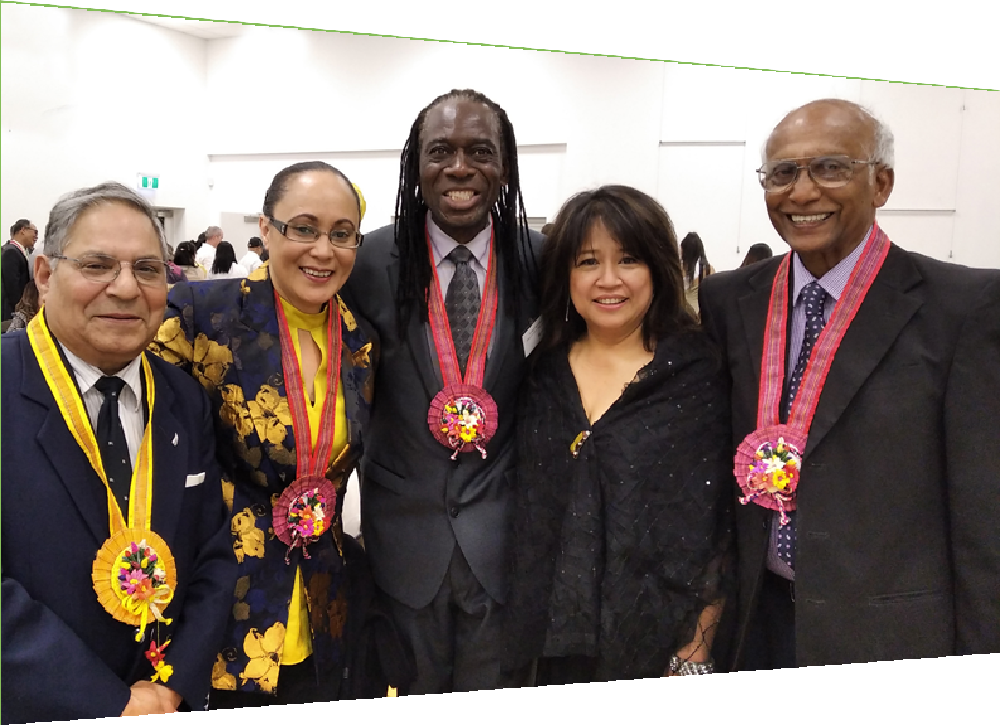
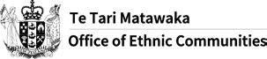

Te Tari Matawaka
Office of Ethnic Communities

A year in review 2019/2020

Contents

Chief Executive’s foreword 3
Word from the Executive Director 5
Who we are 7
Our role 7
An introduction to our work 8
The communities we serve 10
Ethnic communities - The numbers 11
Our teams and their work 14
Community Engagement Northern Team 14
Community Engagement Central Team 14
Community Engagement Southern Team 15
Policy and Research Team 15
Planning Systems and Services Team 15
Our key achievements for the year 16
Ethnic Communities Development Fund 16
Support for Muslim communities following 15 March 2019 17
COVID-19 response 18
National faith/interfaith hui 19
Tackling racism and xenophobia 20
Winning the He Iti Kahurangi Inclusion and Diversity Award 20
Gender, Māori & Ethnic Diversity Stocktake of State Sector Boards 20
Contact Te Tari Matawaka Office of Ethnic Communities 23

Cover page photo: Left to Right Ravinder Powar - President Waikato Multicultural Council, Honourable Jenny Salesa Minister, Fungai Mhlanga - Senior Diversity and Engagement Advisor, OEC, Jovi Abellanosa - Ethnic Development Advisor, for Ethnic Communities (Hamilton City Council), Nagarajah Manoharan (Mano) - President United Nations Association of New Zealand (Waikato Branch).

Event: Pistang Pilipino Celebration 2019 held on 25 October in Hamilton. Hosted by Waikato Filipino Association. (Source: OEC)

2

Chief Executive’s foreword
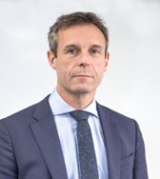
Kia ora koutou katoa

Aotearoa New Zealand’s ethnic communities make up a fifth of our country’s population – almost a million people. We are an increasingly diverse nation, embracing over 200 ethnicities and speaking 185 languages.

As our nation’s diversity has grown, so has the diversity of mahi delivered by the Office of Ethnic Communities. I see this work as an integral part of Te Tari Taiwhenua Department of Internal
Affairs and I am proud of all we do to support ethnic communities.

The Department’s purpose is to serve and connect people, communities and Government to build a safe, prosperous, respected nation. For this to be achieved, every community needs to feel those connections, have the opportunity to participate fully in society, and contribute to building a truly inclusive nation.

The Office of Ethnic Communities fosters those connections by working with departmental colleagues in the charities, citizenships, local government, and community operations
areas – as well as across Central Government – to maximise its support to ethnic communities. The end goal here is for all people to have easy access to the services and information they need to thrive in Aotearoa New Zealand, one of the Department’s strategic aims.

Those who make up Aotearoa New Zealand’s ethnic communities are diverse in every sense. While many have been in this land for generations, others are recent migrants or refugees, so there is a need to provide an incredibly diverse range of support to our communities. One thing they all have in common is a desire to call this country home and feel a sense of
belonging – something reflected in another of the Department’s key outcomes.

In 2019/20 the work of the Office strongly reflected the wide range of support we delivered, underpinned by a strong and unifying sense of increased inclusion.

While there’s no doubt that the past year was a challenging one, there were plenty of celebrations too. The Office of Ethnic Communities hosted many local community events and supported cultural and religious festivals throughout the country to help celebrate and foster our sense of multi-culturalism as a Nation. It also funded almost 200 community initiatives through its Ethnic Communities Development Fund.

3

Another cause for celebration was the appointment of our new Executive Director, Anusha Guler. She brings a wealth of experience and ability to the role and her leadership will provide stability and further strengthen the Office’s performance.

The work of the Office of Ethnic Communities helps to ensure that communities are safe, resilient and thriving. I’m proud of the work we’ve been able to do in support of our ethnic communities, and I look forward to another productive and exciting year ahead.

Ngā mihi nui mahana

Paul James
Tumu Whakarae, Chief Executive,
Te Tari Taiwhenua, the Department of Internal Affairs

4

Word from the Executive Director
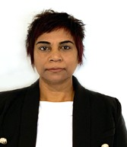
Kia ora koutou katoa

Welcome to A Year in Review from the Office of Ethnic Communities, Te Tari Matawaka. It covers our role in supporting Aotearoa New Zealand’s ethnic communities and highlights what we achieved during 2019/2020.

This last year has been dominated by twin tragedies that have had a profound effect on our ethnic communities and the country as a whole. The terrible events of 15 March 2019 in Christchurch
continue to cause grief and anxiety. Then the advent of COVID-19 brought added uncertainty and disruptions to our daily lives. Ethnic communities were heavily impacted by the economic effects and for many, feeling cut-off from their wider communities took its toll.

These two events have driven our work and, in recent months we have been given more funding which has allowed us to increase our community engagement work and support more community projects and initiatives.

Apart from the important role it played in our office’s COVID-19 response, the Ethnic Communities Development Fund allowed us to support 188 community initiatives in a wide variety of projects. In this document you will find some examples of the great work being done in our ethnic communities with the support of the fund.

After playing a central role in our Government’s initial reaction to the Christchurch attacks, we went to work making sure that Muslim communities in Canterbury and across New Zealand received the support they needed. Our office established the Community Activation Fund with the Ministry of Social Development and Christchurch City Council to support initiatives that improved safety, participation, inclusion and connection among communities affected by the attacks.

We led a series of dialogues aimed at improving the New Zealand Government’s understanding of the concerns and needs of Muslim and other religious communities. These dialogues were complemented by nation-wide faith/inter-faith Hui with key religious leaders from a wide range of communities, including an event in June 2019 where representatives from different faiths were joined by the Prime Minister and the Minister for Ethnic Communities.

Our response to the COVID-19 outbreak is ongoing, and it has focused on providing ethnic communities with the information and resources they need to respond to this crisis. This includes translating and circulating critical information, so it can reach communities more easily and realigning the priorities of the Ethnic Communities Development Fund to support community responses to COVID-19. We partnered with the Human Rights Commission to

5

campaign against a COVID-19-related increase in episodes of racism and xenophobia against our Chinese and other Asian communities.

Improving diversity in the public sector is another key objective for us, and during the last year we ensured that ethnic communities were included for the first time in the 2019 stocktake of Gender, Māori, and Ethnic Diversity on State Sector Boards and Committees.

The above are only a few examples of the wide-ranging work being done by our office. I would like to take this opportunity to acknowledge the dedication of our teams across Aotearoa New Zealand, whose commitment and generosity through this year’s difficult circumstances reflects the spirit of unity and compassion that underlies the work of the Office of Ethnic Communities. It was great to see this recognised in the DIA He Iti Kahurangi Inclusion and Diversity Award that was bestowed on us last November.

Much of our work is done in partnership with others. On behalf on my team, I wish to thank all the community organisations, private sector institutions and government agencies that worked with us in the past year to make a difference. I look forward to continuing our collaboration.

Ngā mihi nui

Anusha Guler
Kaiwhakahaere Matua - Executive Director Office, Te Tari Matawaka, Office of Ethnic Communities

6

“
diversity is valued and supported to flourish, and Aotearoa New Zealand thrives as a result of having welcoming and inclusive communities in which everyone can participate and contribute fully.

Who we are

The Office of Ethnic Communities is the government’s principal advisor on ethnic diversity in Aotearoa New Zealand. We provide information, advice and services to, and for, ethnic communities and administer funds to support community development and social cohesion.

The Office of Ethnic Communities is part of the Department of Internal Affairs. Our work contributes to the Department's overarching outcome: Connected citizens, communities and government. We also contribute to broader public sector efforts to deliver on government goals, especially relating to Safer Communities initiatives, and work to empower ethnic communities to succeed, belong to and contribute to New Zealand society. Our Minister is the Honourable Jenny Salesa, Minister for Ethnic Communities.

Our role
The Office of Ethnic Communities exists to ensure that ethnic communities in Aotearoa New Zealand can access the government information and services that they are entitled to, and can fully participate in, and contribute to society. Our vision reflects this - diversity is valued and supported to flourish, and Aotearoa New Zealand thrives as a result of having welcoming and inclusive communities in which everyone can participate and contribute fully.

Ethnic communities make up one fifth of Aotearoa New Zealand’s population – almost a million people. This group is a mix of those who were born in New Zealand, long-term residents, recent migrants, refugees, workers, students and visitors. They all bring a rich diversity to the nation and contribute to the economy and society.

We have the privilege to meet and talk with members of our ethnic communities on a daily basis and they share their experiences, their challenges and their aspirations with us. Some are New Zealanders who have been here for generations, while others are recent migrants. What they need from us varies hugely. Some need support to access government information and services or overcome language barriers, others want us to help champion their community’s needs to wider Government and, sadly, almost all are looking for support in challenging prejudice and confronting racism in education, employment and other areas of life.

Our role must be varied in turn. We work with a wide variety of groups and agencies to champion community needs, work directly in support of ethnic communities and, manage funds and programmes to help ensure everyone, regardless of ethnicity feels valued and fully
included in society.
7
“

An introduction to our work
Our work to support ethnic communities and help them fully participate in society is set out in our Strategic Framework.

We focus on three interconnected areas:

Working with ethnic communities
- understanding the needs of, and the challenges facing, ethnic communities
- building trust and positive relationships between Government and ethnic communities
- providing advice and support to help ethnic communities access Government information and services
- distributing funding of $4.2 million per year through the Ethnic Communities Development Fund (ECDF) for projects that help communities stay socially connected, grow their skills, celebrate their culture, support employment initiatives, and strengthen community resilience and recovery through the Covid-19 pandemic.

Working with Government
- strengthening Government’s ability to understand the needs of, and address the challenges facing ethnic communities by sharing the views of ethnic communities, and providing informed analysis supported by relevant data
- influencing the development and implementation of Government policy and services to provide better outcomes for ethnic communities
- working to increase the representation of ethnic communities on public and state sector boards.

Influencing wider society
- sharing stories of ethnic communities and challenging stereotypes
- publicly challenging discrimination and supporting campaigns that do the same
- encouraging discussion about the value of ethnic diversity and social inclusion to accelerate social change.

Another significant part of our work is supporting the Minister for Ethnic Communities. This involves:
- providing policy advice
- supporting the many events she attends in her capacity as Minister
- preparing reports, Aides Memoire, and information for responses to Parliamentary Questions, Official Information Act requests and correspondence
- providing information for responses to media enquiries.

8

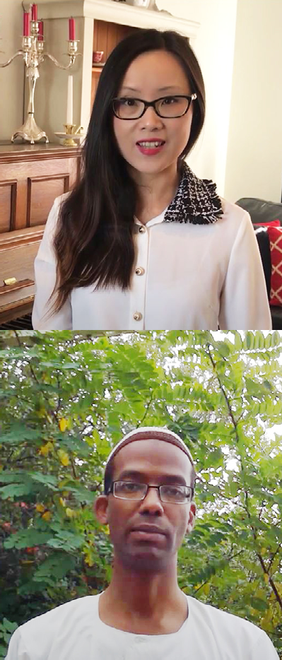
Left: Candy Zhang, Senior Diversity and Engagement Advisor, OEC
Below: Daniel Gamboa, Senior Diversity and Engagement Advisor, OEC

Top: Hisham Eldai, Senior Diversity and Engagement Advisor, OEC
Right: Eileen Yee, Diversity and Engagement Advisor, OEC
9

The communities we serve

New Zealand’s ethnic communities come from diverse geographies and cultures, with a broad range of life experiences. Our mandated communities include anyone in New

Zealand who identifies their ethnicity as Middle Eastern, Latin American, African, Asian, and Continental European.

Ethnic diversity has increased considerably in Aotearoa New Zealand over the past 25 years. There are now over 200 ethnic groups in the population, varying in size from fewer than a hundred to over 150,000 people. Ethnic communities tend to be younger on average than Pākehā/New Zealand Europeans. For many ethnic communities, expression of faith and culture are almost inseparable and are considered fundamental to identity and wellbeing.

While a significant proportion of ethnic groups are small, their impact can be big, particularly in less populated areas. For example, young Filipino families in Southland are said to be transforming the Catholic Church, whose congregation was in decline.
“

Language can play a pivotal role in building and maintaining a sense of ethnic and cultural identity among individuals.
“

Aotearoa New Zealand is linguistically diverse and is home to over 185 different languages with English, Te Reo Māori, Samoan, North Chinese (including Mandarin), and Hindi being the most common. Language can play a pivotal role in building and maintaining a sense of ethnic and cultural identity among individuals, and it is for this reason that there are initiatives throughout the year in Aotearoa New Zealand that support and celebrate heritage and community languages.

10

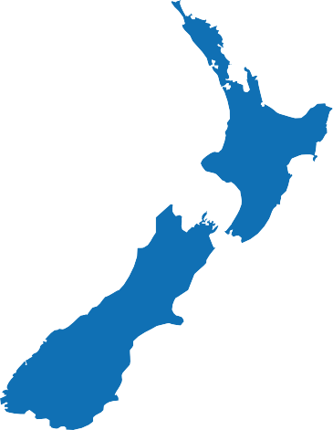
Ethnic communities - The numbers
11
Our population
Arrival group
Born overseas
706K
Born in New Zealand
223K
Note: only counts those who were born overseas and answered the questions.
Top 5 cities
Auckland - 548,022 Wellington city - 53,514 Lower Hutt city - 21, 318
Christchurch city - 72,216
Hamilton city - 39,057

Source: Data was obtained from the 2018 New Zealand Census.

Summary

Ethnic communities | Total population of NZ | Total population (%)
941,571 | 4,699,755 | 20%

Total population by ethnic group

Ethnic grouping | Population
Asian | 718,995
Continental European | 103,050
African | 64,755
Middle Eastern | 28,626
Latin American | 26,145

Arrival group | Number
2 years or less | 130,566
3-4 years | 65,181
5-9 years | 122,004
10-19 years | 204,063
20 years or more | 124,377
Total | 646,191

Religion | Number
Catholicisim | 122,457
Hinduism | 121,032
Christian not further defined | 71,346
Islam | 58,248
Buddhism | 45,978
Sikihism | 40,857
Pentecostal | 17,511
Presbyterian, Congregational and Reformed | 16,467

Languages | Number
English | 822,231
Northern Chinese | 93,621
Hindi | 68,793
Yue | 53,028
Sinitic not further defined | 50,796
Tagalog | 42,966
Panjabi | 34,242
Korean | 30,708

Education
Top religious affiliations
Top languages spoken

Study status
Full-time
239K
Part-time
34K

Highest qualification achieved

Level | EC (%) | NZ (%)
Secondary | 17% | 32%
Secondary (overseas) | 18% | 6%
Post secondary | 14% | 19%
Bachelor degree | 25% | 15%
Post graduate | 16% | 10%

12
Employment
Employment type
Paid employment
421K
Occupation
Employer
22K 42K
Self employed
Unpaid family worker
6K

Occupation | Ethnic community (%) | NZ (%)
Professionals | 26% | 23%
Managers | 15% | 18%
Technicians and Trades Workers | 13% | 12%
Labourers | 11% | 11%
Community and Personal Service Workers | 10% | 10%
Clerical and Administrative Workers | 10% | 11%
Sales Workers | 11% | 9%
Machinery Operators and Drivers | 5% | 6%

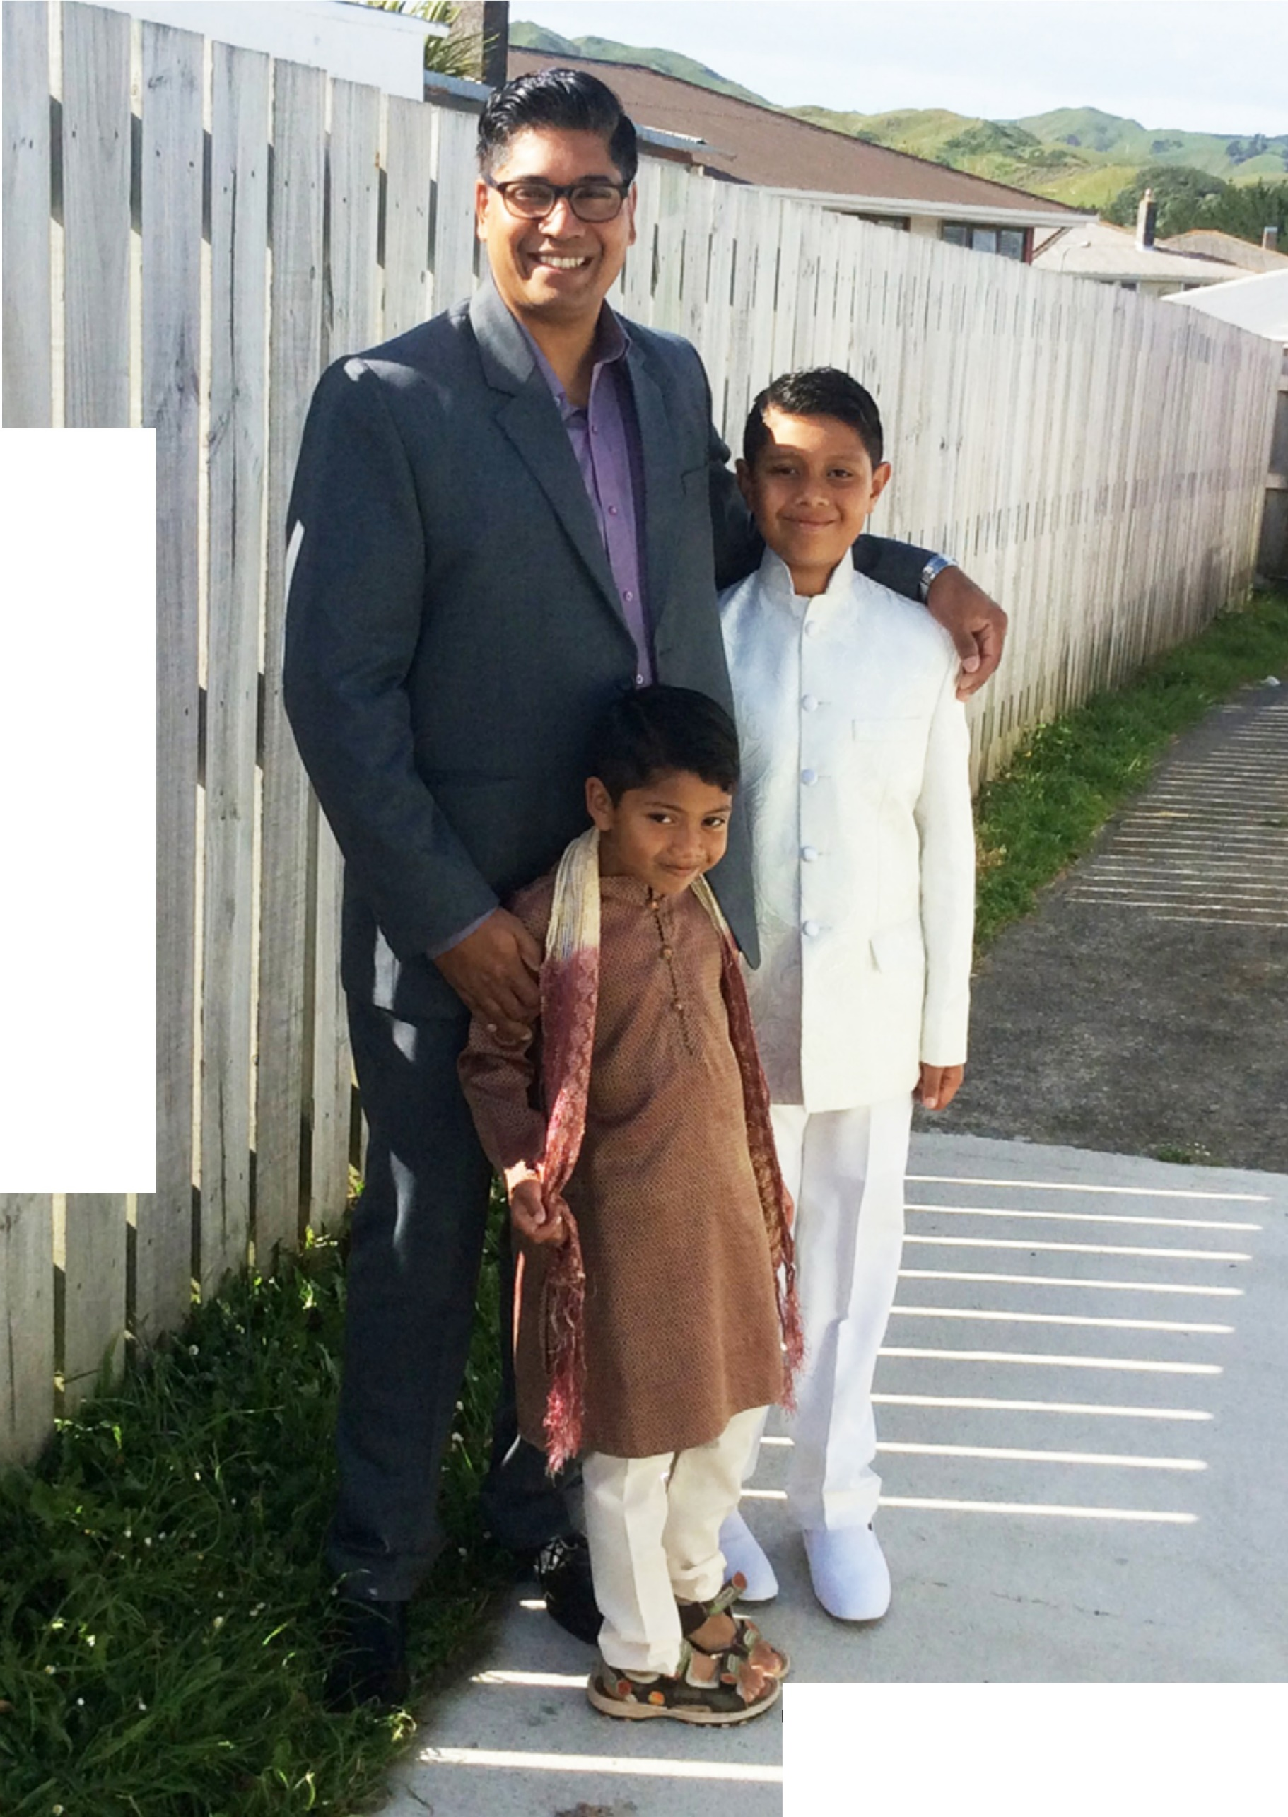

I

Darryl Arnold and his family, Porirua (Source: OEC)

Our teams and their work
We are 35 people working across the country. 74% of us are from the ethnic communities the Office represents and, between us we speak 29 languages. We work in a wide variety of roles, from community engagement and running programmes that directly support communities, to providing policy advice and working with Government to make services more accessible.

We’re made up of five teams:

Community Engagement Northern Team
Covering the upper North Island, the Northern Team is based in Auckland, with a staff member also located in Hamilton. It works directly with local ethnic communities and has a particular focus on making sure Auckland’s voice is heard - the most diverse area of the country and home to over half a million people from ethnic communities.

During the last year the team gained more people and was able to increase its community outreach work, building a presence in Tauranga, Hamilton, and Whangarei. 16 Community Connection Hui were hosted across the region to enhance knowledge of the work of the office, introduce the new staff, and better understand community aspirations. An important partnership was created with Auckland Council to develop a work programme around Diversity and Inclusion with the focus on increasing ethnic representation on governance boards. The team also worked during the COVID-19 lockdown to ensure critical Government information reached deeply into the various communities they support and work with.

Community Engagement Central Team
Covering the central North Island, the Central Team is based in Wellington, with a staff member also located in Napier. It is particularly focused on both reviving and maintaining existing,
and developing new, relationships with ethnic communities in the wider region. The team is conscious of the need to focus on engaging effectively with iwi, Māori and local government, both of which are the highest number in this region. The team is responsible for organising and managing any Parliamentary events on behalf of the Minister for Ethnic Communities, and its Wellington base means that it is often drawn into areas of national level significance, in addition to its regional focus.

Over the last nine months, the team has focused on increasing its knowledge of ethnic community stakeholders and arranging meet and greet events. Team members are building their knowledge of regional iwi groups, and the team has attended training with Te Arawhiti to prepare it to develop and implement an iwi engagement strategy. Members of the team played a lead

14

role in arranging the four Connecting Faith/Interfaith Communities Hui, as well as contributing regionally to key initiatives during the COVID-19 lockdown.

Community Engagement Southern Team
Based in Christchurch, the Southern Team works with communities across the entire South Island. Following the tragic events of March 2019 the team has worked closely with local Muslim communities, helping them access Government support. This work continues.

During the last year the Southern team has focused on expanding its community engagement reach across the South Island including regional outreach and visits, as well as supporting the establishment of a regular ethnic leaders network online meeting with representatives from multicultural councils, refugee settlement providers, newcomer networks and ethnic communities from across the region.

Christchurch, with its significant ethnic community population, remains a focus. The team has supported local initiatives including Ethnic Leaders forums, the Women to Women project, and cultural events and community forums. Southern team members have been heavily involved in the Government response to COVID-19, producing information in multiple languages and working with the Human Rights Commission on a campaign to address COVID-19 related discrimination toward Asian communities.

Policy and Research Team
Our Policy and Research Team provides system leadership in the public service focused on growing social inclusion and valuing diversity along with providing policy advice and ministerial support. Its role is to reflect the views and needs of ethnic communities in policy advice for the Minister for Ethnic Communities and for the rest of Government. The team uses research and data to inform our policy advice and works closely with community engagement colleagues to incorporate the views of ethnic communities into its work.

Planning Systems and Services Team
The Planning Systems and Services team oversees business planning and reporting as well as providing corporate support for the wider organisation. It also manages communication for the Office, including planning, strategy, support of projects and the website, social media and stakeholder channels. The team delivers key programmes that support ethnic communities including the Nominations Service and the Ethnic Communities Development Fund. Following
a successful pilot during COVID-19 it will also set up the Multilingual Information Network which will help share key Government information with ethnic communities.

15

“
The Ethnic Communities Development Fund was created to support ethnic
communities grow their skills, celebrate their culture and take part in
society. This year 188 initiatives have received grants totalling $4.2m.

Our key achievements for the year

Ethnic Communities Development Fund
The Ethnic Communities Development Fund was created to support ethnic communities grow their skills, celebrate their culture and take part in society.

This year 188 initiatives have received grants totalling $4.2m. These grants have supported a range of projects from funding internships for young migrants to research and community cohesion projects. Following the COVID-19 outbreak we focused on initiatives that aim to
increase employment opportunities, community resilience and recovery, and explore different ways for ethnic communities to stay socially connected.

Two case studies that show the variety of the initiatives we support are provided below.
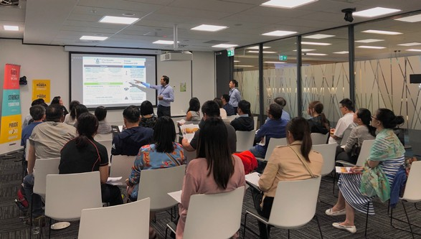
Northern Community Engagement team ECDF Workshop with Chinese Community, March 2020. (Source: OEC)

Flourish Leadership Programme – HMS Trust
This program provided leadership training to 20 women from 14 different ethnic backgrounds in Hamilton, empowering them to overcome their limited voice by providing them the tools to step up and be heard. Through three key learning components - half-day workshops, individual mentoring sessions and group projects that were implemented in the participants’ communities, the women were able to develop leadership skills from multiple perspectives.
16
“

Among the highlights of the Flourish programme were the group projects, which allowed participants to put their new leaderships skills into practice and extended the benefits of the programme to other members of their communities. These projects included an information campaign aimed at combatting casual racism in New Zealand, community gardens for Samoan women and, marketing and promotion for an ethnic women's sisterhood group to address isolation and improve connection within communities.

Another positive, though unexpected outcome of the programme was the women’s willingness to stay connected and expand their networks, which stemmed from their realisation that, as migrants who are learning to find their place in New Zealand, they have more in common than they have differences.

Ramadan welfare and social wellbeing project – United Afghan Association of Canterbury Incorporated
This project sought to reach out to Afghan community members to develop a better understanding of their social and economic wellbeing. This effort resulted in the first true and accurate census of Afghan families and community members, including information about their social and economic status. The project also allowed the United Afghan Association of Canterbury (UAAC) to identify the families that were struggling financially and offer them support through grocery distribution or cash contribution towards their winter power bills.

In addition to the food and financial support to vulnerable Afghan families, a voluntary team of 20 community members put together and distributed an “Eid Gift Pack” to each member of the UAAC. The gift packs, which included traditional Afghani sweets, nuts, dried fruit and Eid gift cards, reached 242 individual families (1190 people altogether) and allowed the UAAC to
connect with community members and provide them comfort and support amid the uncertainty and fear caused by COVID-19.

In the context of this project, the UAAC leadership team was also able to identify and connect with a large group of families who were isolated from the rest of the community. The project received a considerable amount of positive feedback and appreciation from community members, with one family taking a photo of the Eid gift pack and sharing it on social media alongside the message “thanks New Zealand for remembering us”. This feedback clearly indicated that members of the community felt more connected and looked after as a result of this project.

Support for Muslim communities following 15 March 2019
The Office of Ethnic Communities was one of the agencies responsible for supporting the Government’s Christchurch recovery priority, following the tragic events of 15 March.

Our existing relationships with the local Muslim community meant we could quickly reach out to them and help the victims and their families get the support they needed. Our Christchurch staff

17

were on the ground the next day, meeting with community members, sharing information and supporting the welfare centre.

Following the initial response to the attacks we continued to provide support, including establishing the Community Activation Fund with the Ministry of Social Development and Christchurch City Council, supporting the 2019 Hajj which was attended by over 200 Christchurch Muslim community members and, helped form a small leadership group from the Executives of Bishopdale, Al Noor and Linwood mosques as well as the Christchurch Muslim Liaison Group to provide consultation on the March 15 remembrance events.

Building better understanding and connections across communities was clearly more important than ever and Government wanted to hear directly from Muslim groups about their concerns and aspirations, and about what changes could lead to a more inclusive Aotearoa New Zealand.

We organised 13 dialogues and 250 people from Aotearoa New Zealand's Muslim Communities shared their time and ideas. Key themes emerged around - safety and wellbeing, employment, education and the role of the media.

This has been widely shared across Government so that the concerns and needs of Muslim communities are better understood.

A final report - Conversations with Aotearoa New Zealand’s Muslim Communities.

COVID-19 response
As Aotearoa New Zealand went into lockdown for COVID-19 we updated our media platforms to focus only on COVID-19 messaging and help spread the word to ethnic communities.

Our contacts in those communities told us that language was a barrier for a number of people so vital public information was not reaching deeply enough into every community. We responded by producing a series of 68 information videos that translated key COVID-19 messages into
29 different languages. We shared these on our Facebook and YouTube channels – these have received almost 100,000 views. The feedback page from ethnic communities was very positive and community members offered to help spread the information.
“

We responded by producing a series of 68 information videos that translated key COVID-19 messages into
“

29 different languages.
The priorities of the Ethnic Communities Development Fund were also realigned to support ethnic communities while they navigated the impacts of COVID-19. Projects or activities that provided alternative means of staying socially connected, employment initiatives, and community resilience and recovery projects became the main focus of the fund.

18

National faith/interfaith hui
19
Over the last year we have worked with representatives from different faiths to begin an important conversation – how Aotearoa New Zealand could grow social inclusion and address racism, discrimination and religious intolerance.

In June 2019 representatives from different faiths were joined by the Prime Minister and the Minister for Ethnic Communities met with key religious leaders.

During February and March 2020 we organised four connecting faith/interfaith hui in Dunedin, Auckland, Christchurch and Wellington.

Key themes emerged around:

- the value in a national faith/interfaith collaborative voice
- the importance of education in normalising faith and ethnic diversity
- the importance of the media and community-led action to promote and enhance social inclusion, and
- the need to better connect and collaborate with Government.

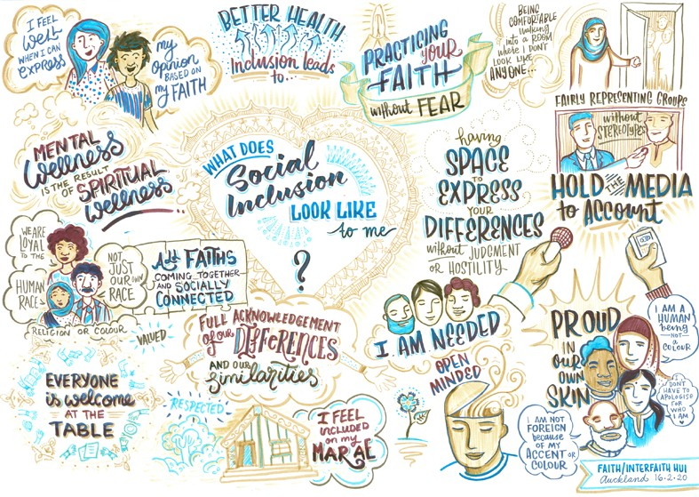
Below: Faith/interfaith hui illustration. (Source: OEC/ League of Live Illustrators)

Tackling racism and xenophobia
We worked in partnership with the Human Rights Commission to support the development of a campaign targeted at bias, racism and xenophobia, particularly in light of the targeting of Chinese/Asian people in the wake of the COVID-19 pandemic.

We supported the campaign and worked with Chinese communities to create videos of real people talking about their experiences of racism and the impact it had on their lives.

Winning the He Iti Kahurangi Inclusion and Diversity Award
In November we were proud to win a Department of Internal Affairs award. This was part of the annual He Iti Kahurangi awards and we were named winners in the Inclusion and Diversity
category. The award is presented to an individual or team who leads by example and champions inclusive behaviours to contribute towards making Te Tari Taiwhenua a place where people are empowered to bring their whole selves to work.
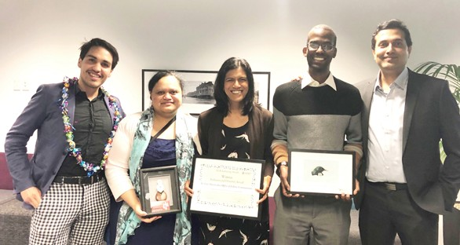

DIA He Iti Kahurangi Awards. Daniel Gamboa, Ida Kohu, Natasha Narayan, Hisham Eldai, Amrit Melant. (Source: OEC)

Gender, Māori & Ethnic Diversity Stocktake of State Sector Boards
Having more diverse voices in Government is crucial to ensuring ethnic communities’ perspectives are represented in decision making. A key Government initiative is increasing the diversity of people on State Sector boards and an annual stocktake is run to assess progress. Working with colleagues from other agencies we ensured that ethnic communities were included in this stocktake for the first time. Work is needed to increase ethnic diversity on boards but we can now formally see the statistics and use them to encourage greater representation.

20

The year ahead
In 2020/21, the Office of Ethnic Communities will continue to:

- support the Government’s response to the Royal Commission of Inquiry into the Attack on Christchurch Mosques on 15 March 2019
- support Muslim communities affected by the Christchurch attacks, to allow them to feel safe and part of their local communities
- support our communities as they recover from the impacts of COVID-19
- increase our community outreach work
- fund projects which promote belonging, participation, inclusion and/or the development of ethnic communities through the Ethnic Communities Development Fund
- broaden the reach of important government information into ethnic households
- promote diversity and inclusion by increasing ethnic representation in leadership and governance roles in the state sector
- strengthen diversity and inclusion through initiatives and programmes to support Ethnic Youth, Women and Businesses
- support the design and delivery of anti-racism initiatives
- build our knowledge base of ethnic communities, their needs and the challenges they face.

We will also build our capacity to:

- strengthen our engagement with Tangata whenua
- strengthen wellbeing outcomes for ethnic communities
- work with other Government agencies to provide a system-wide approach to policy and services that strengthen ethnic community voices and improve outcomes for ethnic communities
- strengthen the labour market and build employment opportunities for members of ethnic communities.

21

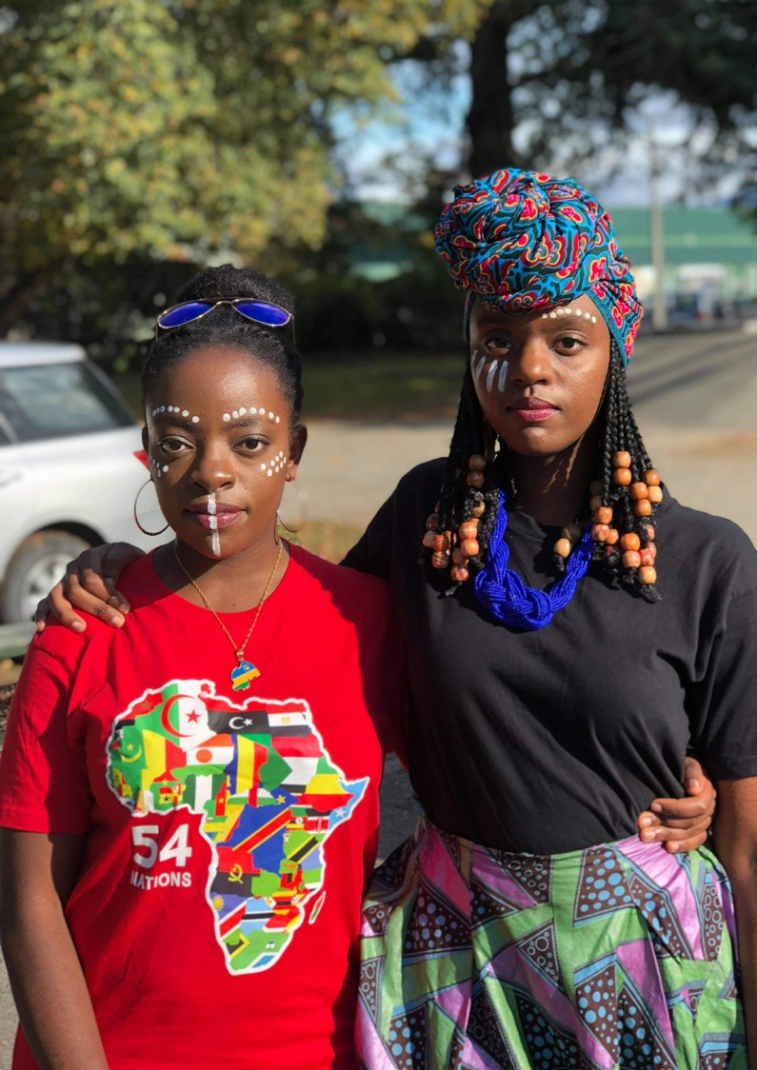
Enatha Musabe and Noella Dushime (Source: OEC).
22
Event: Rwanda Fair, Carterton

Contact Te Tari Matawaka Office of Ethnic Communities

Physical Address

Wellington Office
Office of Ethnic Communities Department of Internal Affairs 45 Pipitea Street
Thorndon Wellington 6011

Auckland Office
Office of Ethnic Communities Department of Internal Affairs Carlaw Park
12-14 Nicholls Lane Parnell
Auckland 1010

Christchurch Office
Office of Ethnic Communities Department of Internal Affairs Level 1
BNZ Centre
120 Hereford Street Christchurch

23
Email:
ethnic.communities@dia.govt.nz
Facebook: @EthnicAConference

LinkedIn: https://www.linkedin.com/company/officeofethniccommunities
Postal Address
Office of Ethnic Communities Department of Internal Affairs PO Box 805
Wellington 6011

Phone
Freephone (within Aotearoa New Zealand) - 0800 656 656
Calling from outside Aotearoa New Zealand - +64 4 495 5784

