Your Voice: Feedback on the Ministry for Ethnic Communities’ draft strategy

September 2021

Message from the Chief Executive
Kia ora koutou,

The Ministry for Ethnic Communities, launched on 1 July 2021, is developing a new strategy to help guide our work over the next four years, and we would like your help. We know success can only be achieved when the Ministry works hand in hand with communities.
Before we launched the Ministry, we asked ethnic communities what areas we should focus on first to make the biggest difference for you. These discussions and many had over the years have helped develop four strategic priorities and goals for the Ministry.
Our priorities were agreed by Cabinet and you will find further details in this document.
We have now turned our attention to the next step – to develop tangible actions to bring the priorities to life and achieve our goal to lift the wellbeing of ethnic communities.
Many of the actions in our draft strategy are what communities have told us would make a difference. Now we are testing our thinking with communities to make sure we are on the right track. We’d particularly like to know what emphasis we should place on our proposed actions.
We also want your thoughts on how we could work with communities to achieve our goals.
We invite you to use your voice and let us know what you think about our proposals.
You will find our draft strategy and details about how you can give your input in this document.
I want to ensure that your views will be reflected in our final strategy that will be published early next year. Ethnic voices continue to drive where we put our effort. That is how it should always be.
I am looking forward to your participation in this engagement.
Ngā mihi nui,

Mervin Singham
Chief Executive
Ministry for Ethnic Communities

About the draft strategy

The Ministry for Ethnic Communities is developing a new strategy to help guide our work over the next four years, and we would value your help to shape it.
In April and May this year, the Minister for Diversity, Inclusion, and Ethnic Communities, Hon Priyanca Radhakrishnan, heard from hundreds of people about their views on what the new Ministry should focus on first in order to have the biggest impact for ethnic communities.
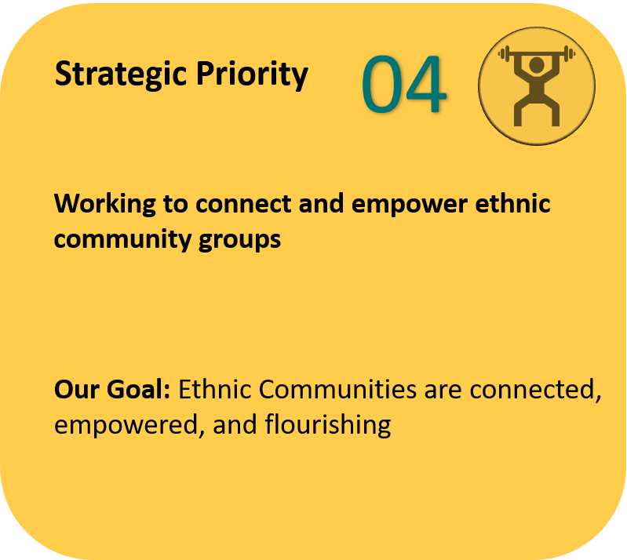
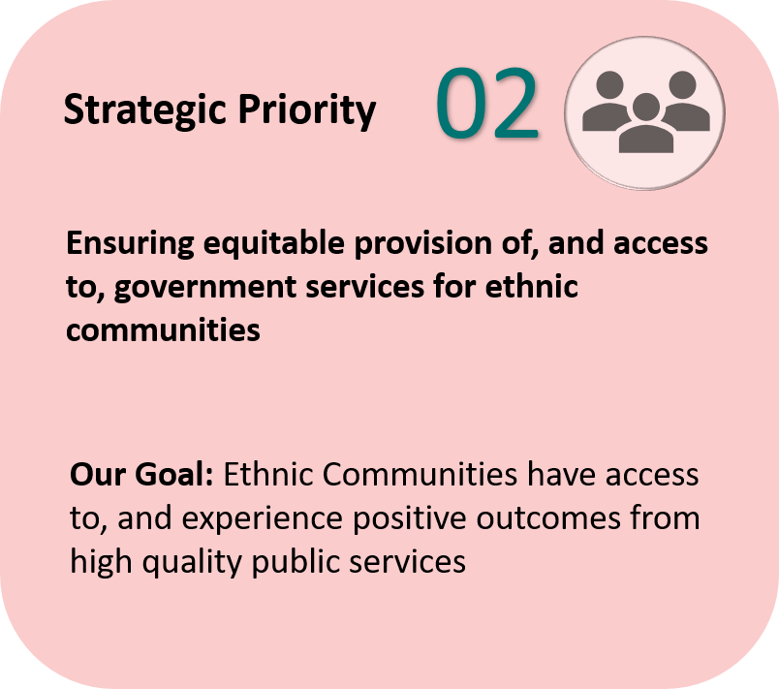
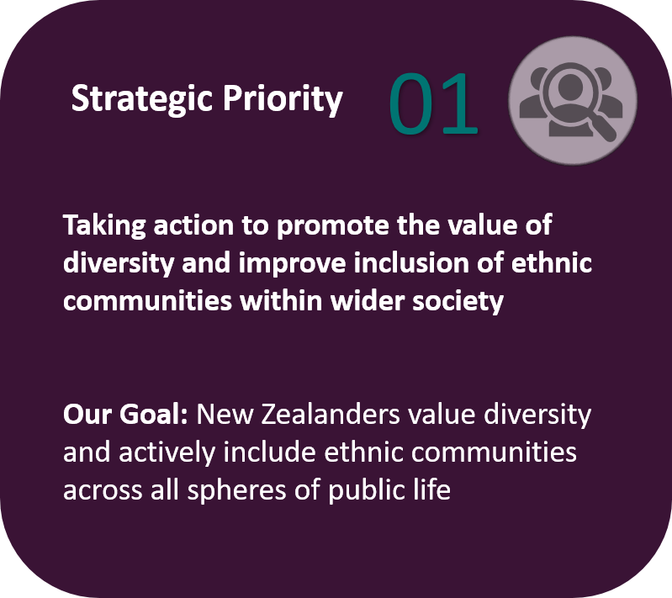
These discussions and many had over the years have helped develop the following four strategic priorities and goals for the Ministry. These priorities have been endorsed by Cabinet as the Ministry’s priorities over the next few years.
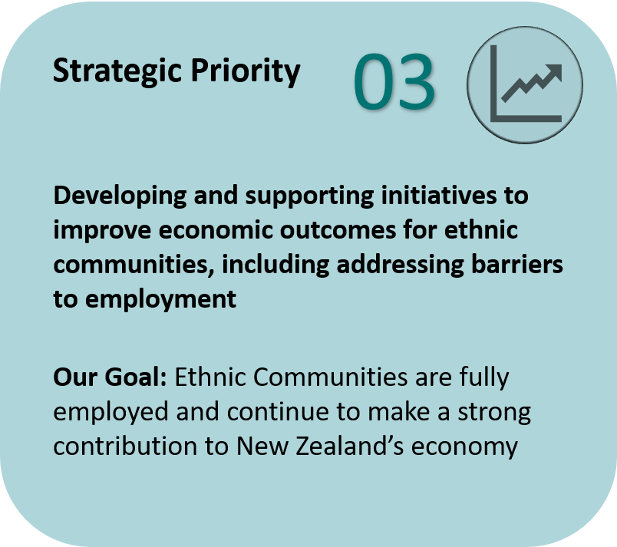

The next step is to bring these priorities to life.
We have developed a draft strategy to help us achieve our goals, working closely with communities and the rest of the public sector.
On pages 5 to 8 of this document, you will find the draft strategy with a set of actions planned for the next 4 years. Many of the actions have been raised by communities as things that would make a real difference.
We would like to hear your thoughts on the draft strategy, including where we should place our efforts with regards to specific actions in order for you to see the biggest and most tangible difference for ethnic communities. We also want to hear from you about what is missing or could be improved.
You may notice that some of the proposed actions are not very specific. Once the strategy is agreed, we will develop individual work programmes and action plans for each action.
The draft strategy and suggested questions are on pages 5 to 8 of this document. This is arranged by priority.
Please note that some of the proposed actions are cross-cutting and can serve to achieve more than one goal. An example of this, is the Ethnic Communities Graduate Programme. This could sit across all priorities in the tables below.

How to provide feedback
We are seeking feedback on the draft strategy between from now until Friday, 5 November 2021. You can provide feedback through our online focus group engagements or by completing our online survey. The online survey is an opportunity for more people to give us feedback from where they are, and when they can. A link to the survey and details for online sessions are available on our website.

Next steps
Ethnic voices will continue to shape the Ministry’s goal to contribute to an Aotearoa New Zealand that reflects and responds to the aspirations and needs of all New Zealanders, regardless of their ethnic background.
Your feedback will help the Ministry finalise and agree a Statement of Intent that includes the Ministry’s strategic intentions for 4 years, and a draft statement of Performance Expectations which will include the Ministry’s first annual plan. Our final strategy will be published in early 2022.
We will develop a work programme for the agreed actions. We will revise it annually to reflect changing circumstances and to check which actions are helping to achieve our vision, and which aren’t. Any resulting changes to the Strategy will be published on our website.
We thank you for giving your voice to help shape our first strategy as a new Ministry. To make the difference communities desire, we must continue to work hand in hand.

Priority 1: Taking action to promote the value of diversity and improve inclusion of ethnic communities within wider society
Communities told us this priority matters because | Our vision for this priority | The difference we want to see for communities | To achieve these differences, we have actions planned for the next 4 years | We will have made a real difference when
- The opportunity cost of not harnessing the diversity that exists in New Zealand is significant, and New Zealand is stronger when everyone is an advocate for the value of diversity and against racism and discrimination  - The benefits of diversity are unlocked when ethnic communities have a sense of belonging and their culture and values are recognised  - Our diversity as a nation offers strength of perspectives, experiences and connections that can benefit all New Zealanders if treated as a taonga. For communities, the desire to achieve true multiculturalism while maintaining a recognition of Aotearoa's bicultural context is a significant aspiration  - The social, cultural and economic contributions of ethnic communities must be shared with all New Zealanders, so they recognise the value that increasing ethnic diversity adds to New Zealand  - All New Zealanders regardless of their background, should be free to express their cultural identities and freely in private and public spaces, and without fear or discrimination, especially important for young ethnic people to feel valued and included in their learning environments | - Diversity and inclusion is mainstream, and New Zealanders demonstrably appreciate the value that ethnic diversity brings and have incentives to be more inclusive  - Aotearoa New Zealand is a truly inclusive nation where people can participate fully and without fear of discrimination, racism, or bias  - Ethnic communities can freely express their culture and identity and can be valued for doing so | - Instances of racism and discrimination reduce  - The achievements and contributions of ethnic communities in areas such as social, economic, cultural, sport, and academia are understood and celebrated  - Central and local government decision-making reflects the diverse needs and aspirations of all New Zealanders  - Diverse languages, art, culture, and practices are widely visible and highly valued in all spheres of the community  - Accurate positive representations of ethnic people and communities in the media | Some work is already underway  - Improve the representation of people from ethnic communities on public sector boards and committees  - Ongoing support for the implementation of the Royal Commission of Inquiry into the Christchurch Terror Attacks (RCOI) recommendations – including supporting the Ministry of Social Development as it develops and implements the Social Cohesion work programme  - Support community initiatives that promote diversity and inclusion, including the Race Unity Speech Awards  - Supporting other agencies on work to reduce and eliminate racism and discrimination  And there is other work we could progress  - Collaborate with the Ministry of Education to deliver on its work programme to address racism and discrimination in the education system and other places of learning  - Commission and publish research on the value of diversity and its contribution to Aotearoa New Zealand  - Develop initiatives that bring stories of ethnic communities into the mainstream media, and empower ethnic communities to use all media to tell their own stories  - Create opportunities to highlight findings related to attitudes towards diversity and inclusion in New Zealand gathered from existing surveys (e.g. General Social Survey)  - Lead the establishment of a measure of organisational Cultural Intelligence as a standard self-assessment practice within the public service  - Actively encourage more opportunities for inter-cultural dialogues within and across communities, including with tāngata whenua | - The proportion of appointments to public sector boards and committees increase  - More stories of success, and more positive stories by ethnic communities, are told in mainstream media  - Cultural Intelligence is evident in public services  - Over time, incidences of racism and discrimination in places of learning decrease  - Over time, there are more New Zealanders who rate diversity as beneficial to the success of Aotearoa New Zealand as a nation
Questions to consider: |  |  | As a package, do you think the proposed actions (new and existing) will help make a tangible impact for communities?  Which of the actions do you think would make the biggest and most tangible impact for communities?  What could be changed or what is missing?
 | Finally, what excites you about this proposal for Priority 1: Promoting the value of diversity and inclusion? What worries you about this proposal for Priority 1?

Priority 2: Ensure equitable provision of, access to, and outcomes from government services for ethnic communities
Communities told us this priority matters because | Our vision for this priority | The difference we want to see for communities | To achieve these differences, we have actions planned for the next 4 years | We will have made a real difference when
- High-quality, equitable and responsive government services designed with diverse needs in mind will create improved social and economic outcomes for New Zealand  - Such services are wide ranging but include employment, housing, social welfare, health, education, mental health, English language and literacy support, drugs and addiction support, and immigration services  - There is a strong desire, particularly for newer arrivals to New Zealand, for greater awareness and information about how to access and navigate these services – including ensuring that language is not a barrier  - A more visible representation of ethnic communities in decision-making and meaningful ethnic information in official data will contribute to improving outcomes for communities  - Working across government to build cultural competency and understanding is vital if government services are to better meet the needs of New Zealand’s diverse communities | - Government policies and services across the system address the priorities and challenges faced by ethnic communities, and are coherent, evidence-based and relevant for ethnic communities  - A culturally, linguistically and evidence-based government will enable everyone, regardless of their background, equitable provision of, access to, and outcomes from government services  - The design of front-line services meets the needs of New Zealanders, so that New Zealand’s diverse communities can experience more positive and successful outcomes | - The outcomes for ethnic communities from government services are better understood as a result of better quality, and more up to date, official data on ethnic communities  - The system is more aware of, and becoming more responsive to, the unique needs and aspirations of ethnic communities  - Decision-making is more directly influenced by input from, and consultation with, ethnic communities with diverse needs | Some work is already underway  - Ensure ethnic communities are represented in the COVID-19 vaccine rollout  - Work with StatsNZ to develop an approach to improved official data gathering and reporting on the outcomes from government services for ethnic communities  - Develop and deliver resources for government agencies to increase cultural capability and intelligence  - Build our internal data and insights capability  - Improve the delivery of information on services to ethnic communities through the Multi-Lingual Information Network  - Provide guidance to government departments on how to engage with ethnic communities on potential changes to systems, services and processes  - Provide secondary policy advice to public service agencies to ensure the voice of ethnic communities is reflected in government policies  And there is other work we could progress  - Produce insights to monitor public services agencies with regard to the outcomes for ethnic communities across a range of measures (including a bi-annual State of the Nation report)  - Develop an ethnic community policy development tool for use within government so that policy decisions consider the impact on ethnic communities  - Partner with local government to improve services for the local ethnic community in the regions  - Develop a best-practice crisis management approach that enables the Ministry to be a conduit between ethnic communities that are impacted and relevant government agencies for additional public service support | - The proportion of ethnic communities who have received a COVID-19 vaccine is comparable to the New Zealand European population  - Increased cultural competency within the public sector  - The impact of all new government policy has been assessed using the ethnic policy development tool  - We can see a measurable improvement in the outcomes for ethnic communities from key government services (e.g. Employment, Housing, Education, and Health) – requires base data to make initial measurement
Questions to consider: |  |  | As a package, do you think the proposed actions (new and existing) will help make a tangible impact for communities?  Which of the actions do you think would make the biggest and most tangible impact for communities?  What could be changed or what is missing?
 | Finally, what excites you about this proposal for Priority 2: Improve outcomes from government services? And what worries you about this proposal for Priority 2?

Priority 3: Developing and supporting initiatives to improve economic outcomes for ethnic communities, including addressing barriers to employment
Communities told us this priority matters because | Our vision for this priority | The difference we want to see for communities | To achieve these differences, we have actions planned for the next 4 years | We will have made a real difference when
- Hiring decisions should be fair to enable ethnic communities to participate fully in New Zealand, and contribute their skills to the New Zealand economy  - People for whom English is not a first language and with overseas qualifications and experience want opportunities to access gainful employment  - Ethnic communities who are employed want pathways for career progression and more representation at higher levels of government  - Many of these outcomes are potentially driven by employer unconscious bias or overtly discriminatory and racist hiring practices  - Opportunities for self-employment and support for aspiring business owners to start to develop and grow their businesses is critical for ethnic and small business enterprises to flourish for the benefit of New Zealand | - Members of ethnic communities have equal access to meaningful employment opportunities and comparable economic outcomes with the rest of the population  - Ethnic communities are truly valued for the contribution which they make to the economy, and to workplaces.  - An inclusive labour market environment that enables ethnic communities to pursue jobs, career and business opportunities matched with their skills, experience, and aspirations | - More ethnic community members are gainfully employed and have opportunities for career progression  - More employers speaking to and championing the value of diversity in workplaces  - Ethnic communities are increasingly seen as key contributors to the New Zealand economy, and a valued addition in all workplaces  - New Zealand’s public service is more representative at all levels  - Ethnic community members are increasingly confident in the workplace | Some work is already underway  - In collaboration with the Ministry for Social Development and the Ministry for Business, Innovation, and Employment, implement the Employment Action Plan that prioritises recent migrants, former refugees, and ethnic community members who face multiple barriers to enter and succeed in the labour market, including women  The Action Plan includes planned work on improving the ethnic pay gap, career progression, research on labour market outcomes and economic contribution of ethnic communities, work to address employer bias, and addressing migrant exploitation  - Continue to develop an enduring support infrastructure for the graduates and hiring agencies for the Ethnic Communities Graduate Programme so that the experience is meaningful for both parties  - Support community-led initiatives to improve employment outcomes for ethnic communities  And there is other work we could progress  - Explore an expansion of the Ethnic Communities Graduate Programme to provide opportunities for those who face the greatest barriers to secure employment in the public service, and potentially the private sector  - Commission work to understand the barriers to the recognition of overseas qualifications and experience  - Create opportunities to leverage the knowledge of ethnic business owners (including with international markets), and to connect, support, and empower them, including connection with tāngata whenua businesses  - Develop resources for workplace cultural competency for use across public and private sectors, and for ethnic communities | - The number of ethnic community members gainfully and meaningfully employed in jobs that match their skills and experience increases  - More former refugees (resettled community) are in gainful employment in their first 5 years in New Zealand  - The ethnic pay gap narrows. A potential measure is reviewing the percentage of ethnic communities on more than $100K salary, relative to the rest of the population increases (as a measure of career progression into leadership positions)  - Number of those working in the public service from an ethnic community background increases at all levels, including at leadership levels  - Barriers to the recognition of overseas qualifications and experience are better understood, and steps to address these barriers are identified
Questions to consider: |  |  | As a package, do you think the proposed actions (new and existing) will help make a tangible impact for communities?  Which of the actions do you think would make the biggest and most tangible impact for communities?  What could be changed or what is missing?
 | Finally, what excites you about this proposal for Priority 3: Improve economics outcomes for ethnic communities? And what worries you about this proposal for Priority 3?

Priority 4: Connecting and empowering ethnic community groups
Communities told us this priority matters because | Our vision for this priority | The difference we want to see for communities | To achieve these differences, we have actions planned for the next 4 years | We will have made a real difference when
- The diversity of our ethnic communities is a real asset to Aotearoa New Zealand. However, this diversity can be a real challenge for those who are seeking to provide services. We see a real role for community groups to help bridge any gaps, and communities have a strong desire to be empowered to support themselves  - All community groups, regardless of their current influence, want resources and tools that build their capacity to support their communities and be more self-sufficient. Examples include leadership and governance training, closer ties between community and government, community funding and establishing community role models  - Communities have also been very clear that they are motivated to build better connections within ethnic communities, between ethnic communities and wider New Zealand society, and with tāngata whenua. Building real and lasting connections is a key part of ethnic communities truly becoming a respected part of the fabric of New Zealand’s society  - Creating opportunities to allow ethnic communities to influence decision-making is critical to empowerment. For more well-established communities these opportunities often exist, but newer, emerging and smaller ethnic communities often need support to access those same opportunities  - It’s important that ethnic communities have a voice in the important conversations, are confident in navigating government, and that they shouldn’t rely on the Ministry to be the bridge between government and communities | - All ethnic community groups feel like they can access the tools, training, skills and connections they need to support their community to achieve their aspirations  - Ethnic communities feel connected and a part of wider New Zealand society  - Ethnic communities have a real and meaningful voice in the important conversations | - Larger and more well-established community groups and organisations are empowered and supported to support smaller and emerging community groups  - Ethnic communities have a more coherent and articulate voice when engaging with government  - Ethnic community groups are more aware of, and organised to access, the range of government services and support available  - Ethnic communities have better connections with government, wider New Zealand society and with tāngata whenua | Some work is already underway  - Support and fund community-led capability development initiatives and initiatives to celebrate diverse cultures  - Host pan-ethnic stakeholder events for communities to network and share knowledge  - Connect ethnic communities with other parts of government, including other funders  And there is other work we could progress  - Establish an Ethnic Leaders Forum to connect pan-ethnic leaders and help bring the voice of communities to decision makers  - Collaborate with other public agencies to support and empower youth from ethnic communities  - Develop contemporary Ethnic Young Leaders and Women Leaders programme to enable these potential key actors in Aotearoa society to participate more fulsomely in democratic processes  - Partner with other population agencies, such as the Ministry for Women, and the Office for Seniors, to address common challenges across population groups  - Make funding and other opportunities for capability development (e.g. governance training) more easily accessible for smaller and emerging ethnic communities, and for marginalised groups such as youth, women, seniors, the rainbow community, and former refugees  - Create more intentional opportunities for sharing skills and experience within and between ethnic communities, including with tāngata whenua  - Revisit the purpose and priorities of initiatives the Ministry funds to ensure that they remain relevant over time, and they incentivise collaboration  - Establish an award to recognise the contribution and impact of ethnic community groups in Aotearoa New Zealand | - The voice of ethnic communities consistently features in decision-making  - Ethnic leaders have a coherent and cohesive voice on important issues that ethnic communities face  - The amount of funding (Lottery Grant, COGS, Local Councils, Philanthropic, etc) received by ethnic community groups increases  - More ethnic young people, women and men are sought after as contributors to local and central government elections, board appointments and employment in the public sector  - There is increased collaboration across communities.
Questions to consider: |  |  | As a package, do you think the proposed actions (new and existing) will help make tangible impact for communities?  Which of the actions do you think would make the biggest and tangible impact for communities?  What could be changed or what is missing?
 | Finally, what excites you about this proposal for Priority 4: Connect and Empower Ethnic Community groups? And what worries you about this proposal for Priority 4?

