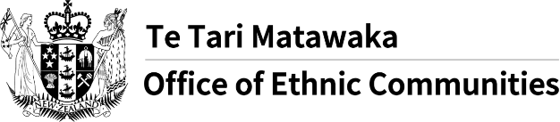
Office of Ethnic Communities launches COVID-19 survey

Frequently asked questions
What’s the purpose of this survey?
To capture a snapshot of the experiences and concerns of ethnic communities in relation to COVID-19 pandemic.
Who is conducting this survey?
The Office of Ethnic Communities – which is a part of the Department of Internal Affairs.
What will you do with the information provided in the survey?
The results and analysis from the survey will be used to inform the continual improvement of COVID-19 related policies and initiatives from the New Zealand Government to seek better outcomes for ethnic communities.
Who can complete the survey?
Anyone in New Zealand who identifies their ethnicity as Middle Eastern, Latin American, African, Asian, and Continental European, and is 16 years old and over.
How long will it take me to complete the survey?
The survey should take approximately 15 minutes to complete.
How will you protect my personal information?
The information you provide in this survey is anonymous and will not be associated with you. Please do not provide identifying information about yourself or anyone else when answering text response questions, for example, by including a name in your response. If you do supply personal details, they will be kept confidential in a secure environment.
You can request a copy of your identifiable information at any time by contacting privacy@dia.govt.nz.
Will the results of the survey be available to the public?
Yes

