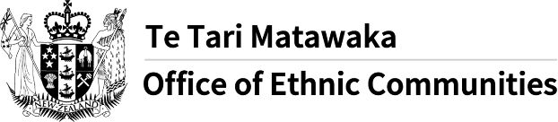
Office of Ethnic Communities launches COVID-19 survey
- The Office of Ethnic Communities is asking people from ethnic communities across Aotearoa New Zealand to share their perspectives, experiences and concerns regarding the challenges they are facing due to COVID-19.
- COVID-19 is likely to exacerbate inequalities that already exist in society. Some of the immediate impacts, including effects on employment, are well known; but we want to ensure that ethnic communities’ perspectives and concerns continue to shape the government's responses to the pandemic.
- The Office of Ethnic Communities has designed a survey to capture a snapshot of the experiences and concerns of ethnic communities in relation to COVID-19.
- Information provided in this survey is anonymous and will be used for research purposes by the Office of Ethnic Communities – which is a part of the Department of Internal Affairs.
- The survey will be open from Friday 26 February to Friday 26 March 2021.
- You can ask someone to help you complete the survey.
- To access the online survey please click on the following link: https://www.surveymonkey.com/r/OECCOVID-19SurveyMIN
This message has been translated by Translation Services, Department of Internal Affairs and shared by the Multilingual Information Network. For more information on the network visit the Office of Ethnic Communities website.

