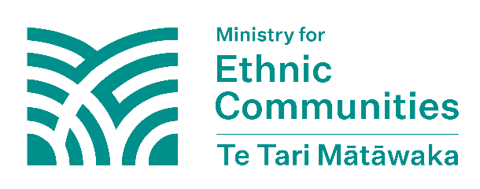
Faragelin dibadda ah ee
New Zealand
Adeegga Sirdoonka Nabadsugidda New Zealand (NZSIS) wuxuu far agelinta shisheeye ku qeexaa fal ay ku kacdo waddan shisheeye, oo inta badan ku dhaqma qaab wakiil ah, kaas oo loogu talagalay in lagu saameyo, lagu carqaladeeyo ama lagu dumiyo danaha qaranka New Zealand iyadoo loo adeegsanayo hab khiyaano, musuqmaasuq ama qasab ah. Hawl diblumaasiyadeed ee caadiga ah, u ololaynta iyo dadaallada kale ee dhabta ah ee la rabo in lagu helo saameyn looma tixgeliyo faragelin.
Xaashidan macluumaadka “dal shisheeye” macnaheedu waa dal kasta oo an aheyn New Zealand. Eraygan waxa loo adeegsadaa wadamada ka baxsan New Zealand.

Faragalenta shisheeye waxay wax u dhimaysaa xuquuqda iyo xorriyadaha Bulshooyinka Qowmiyadaha
Faragelinta shisheeye waa marka dawladaha shisheeye ay isku dayaan inay farageliyaan New Zealand si ay u gaaraan ujeedooyinkooda. Dawladahan shisheeye waxay rabaan inay xakameeyaan oo beddelaan bulshada New Zealand, danaha, iyo dabeecadaha. Waxay tan u sameeyaan si ay u yeeshaan saameyn iyo xakameyn badan.

Faragelinta shiisheeye waxay dhaawacdaa madax-bannaanida New Zealand, dimuqraadiyadda, dhaqaalaha, sumcadda, iyo bulshada." Bulshooyinka Qowmiyadaha ee New Zealand waxay ka heli karaan dareenka aan loo baahnayn dowladdaha shiisheeye, taas oo ka dhigaysa inay dareemaan ammaan darro oo waxyeello u geystaan xuquuqdooda iyo xorriyaddooda. Dhaqdhaqaaqyada diblomaasiyadeed ee caadiga ah ee ka dhexeeya waddamadu maaha faragelin shiisheeye.

Sidee faragelinta shiisheeye ugu dhici kartaa Beelaha Qowmiyada?

Faragelinta shiisheeye ee ay la kulmaan Bulshooyinka Qowmiyadeed way adag tahat in la arko. Waa kuwan tusaalayaal hawlo faragelin shiisheeye ah oo ay waddo dawlad shiisheeye ama qof faragelin shiisheeye ugu samaynaya iyaga gudaha New Zealand:

- isku dayaya in uu xakameeyo oo uu cabsi geliyo bulshooyinka ama bulshada organisations/groups
- diidmada hab-socodka ama soo saarida dukumentiyada rasmiga ah si loo dhibaateeyo, loo cabsi geliyo loona xakameeyo bulshooyinka iyo falalkooda
- ka qaadida ama ku hanjabaya inay ka qaadi doonto fiisaha, baasaboorada, ama dukumentiyada kale ee rasmiga ah ee dadka New Zealand si loo dhibaateeyo, loo cabsi geliyo loona xakameeyo bulshooyinka iyo ficiladooda
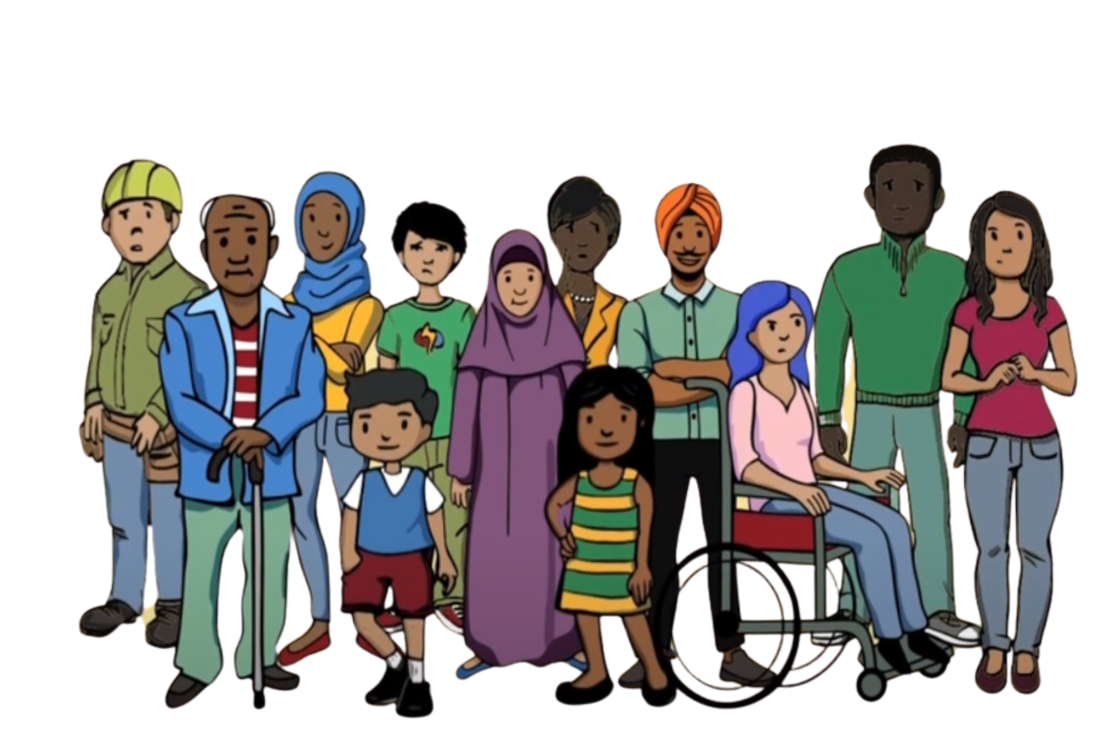
- handadaada dadka ku nool New Zealand, ama qoysaskooda ku nool dibadaha (ay ku jiraan hanjabaad iyo kadeedis dhanka warbaahinta bulshada)
- ku qasbida dadka inay ku noqdaan wadankii ay ka yimaadeen iyagoon raali ka ahayn
- daba-galka iyo la socodka aan la ogolayn ee dowladda shiisheeye ku hayso bulshada si loogu handado ama dadka loogu cabsi geliyo
- in la isku dayo in laga hortago kooxo ama bulshooyin gaar ah in ay si cad u wadaagaan fikradahooda ama ra'yigooda ka duwan kan dawladda shiisheeye iyaga oo isticmaalaya hanjabaad ama cagajugleyn
- isku dayida in la joojiyo dhacdooyinka ka dhacaya New Zealand si looga ilaaliyo dadka inay soo bandhigaan fikradahooda ama waxay aaminsan yihiin in dawlad shiisheeye aysan ku raacsanayn
- u gudbinta hanjabaadaha dawlad shiisheeye ee bulshada ku nool New Zealand
- isku dayaya in uu wax ka beddelo sida doorashooyinka iyo hababka kale ee dimoqraadiyadu u shaqeeyaan

