Examples of foreign interference   
Here are some examples of foreign interference experienced by Ethnic Communities. These examples are based on experiences Ethnic Communities have shared with the Ministry for Ethnic Communities.

In these examples “foreign state” means **any country other than New Zealand**. This term is used to refer to countries outside of New Zealand.

**Example 1**

Community members often want to travel to their home countries to see their friends and families. For this, they might need to use consular services. These services are provided by a country’s embassy or consulate to its citizens abroad and include issuing passports, visas, travel documents, and handling other legal matters.

Members of an ethnic community in New Zealand were told by consular staff that they won’t get passport renewals or visas if they associate with groups or people in New Zealand who criticize that foreign state. This makes the community feel unable to express their views, talk to certain people, protest, or join groups. These restrictions make the community in New Zealand feel trapped and controlled by the foreign state. When people can’t travel to see their family and friends, it has a big impact on their families and their wellbeing.

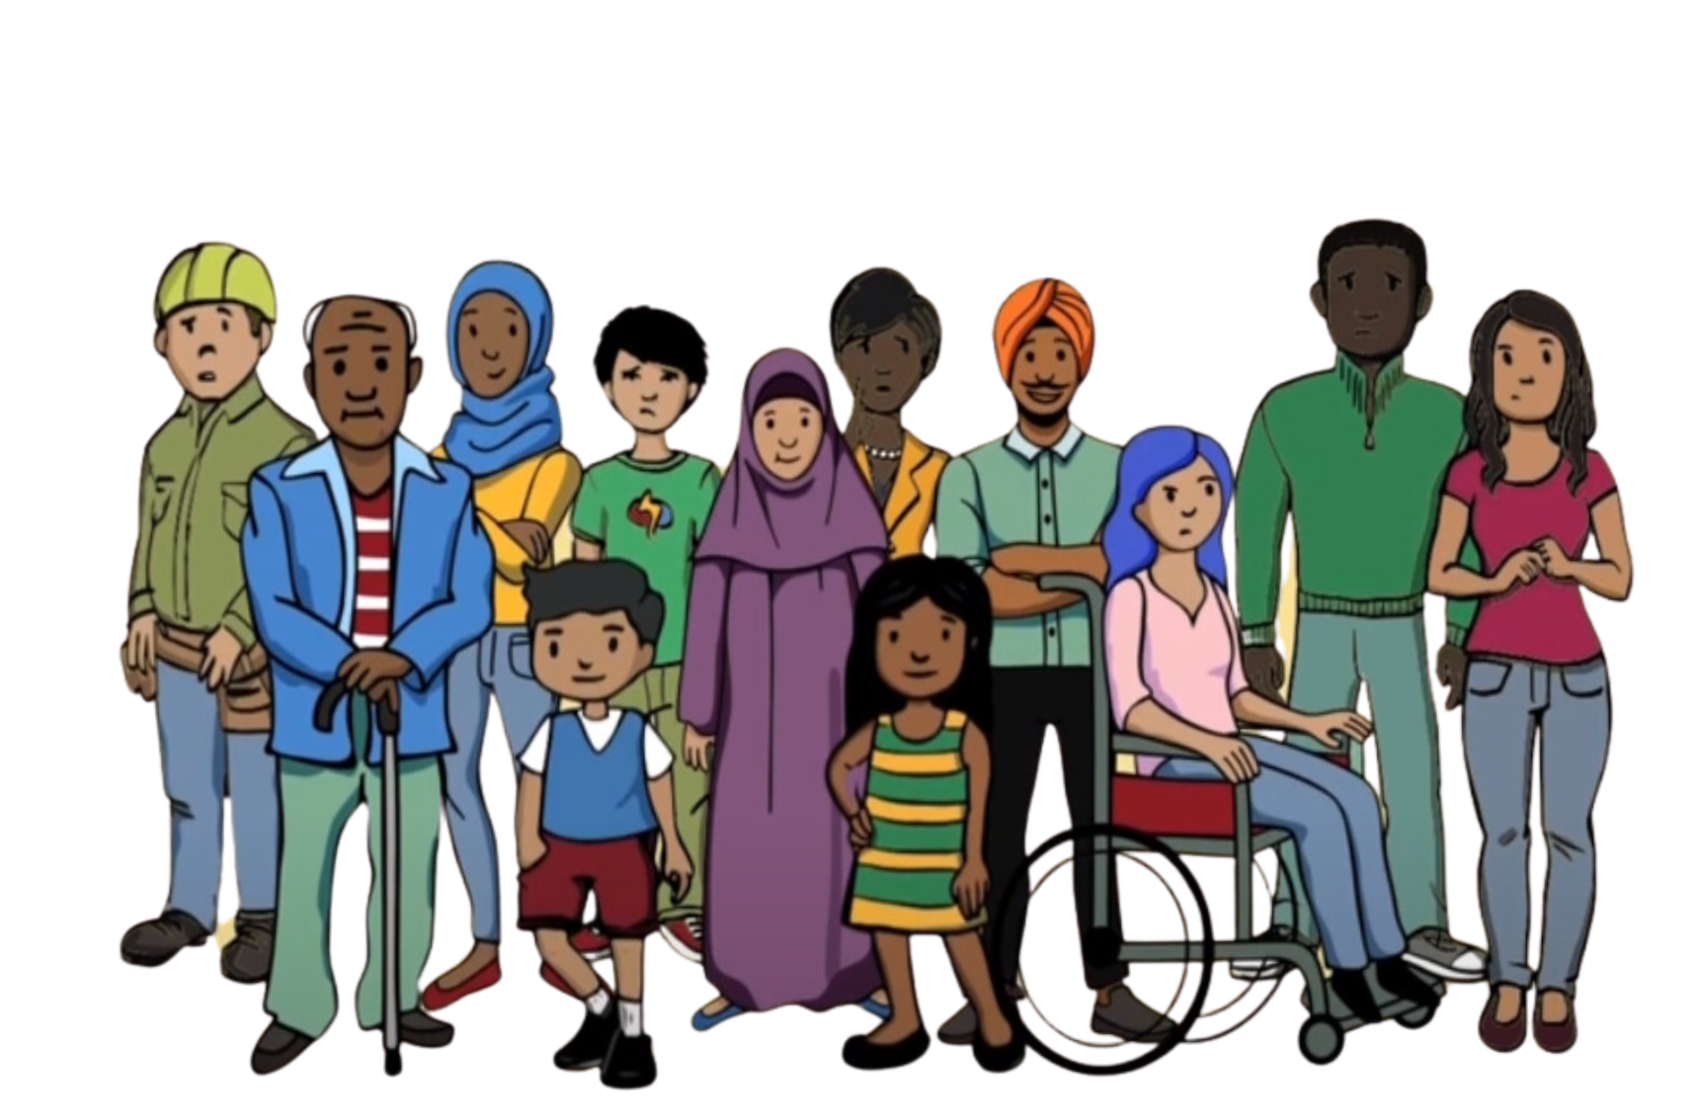

**Example 2**

In a community, a place of worship was targeted by foreign interference. A new member, who seemed very religious, became very involved in the communities’ religious activities. They started to talk a lot about politics and told people to support their country of origin’s government. They wanted sermons to be about politics. The new member also tried to stop people from criticising the foreign state. They were asked to do all of this by the foreign state.

Community members who criticised the foreign state, when the new member was present, got anonymous threats through text messages and social media. This hadn’t happened before the new member arrived. The community suspected that the new member was reporting back to the foreign state. They saw that these issues only started after the new member joined and tried to make people support the foreign state. This situation made people feel unsafe and distrustful of each other. It became hard for the community to come together and focus on their faith at this place of worship.

**Example 3**

In a community, people noticed suspicious behaviour from one of their community members. This person seemed to be always asking about the political views and activities of other people in the community. The community found out that this person had been asked by the foreign state to report to their Embassy in New Zealand about people who criticised their country of origin’s government.

Some community members who had talked to this person and criticised the foreign state had unexpected problems, like visa issues and questioning at the airport when they arrived in their country of origin. This had never happened to them before. They think these problems happened because their conversations with that community member were reported to the Embassy. This made people in the community afraid and distrustful, so they stopped expressing their true opinions.

**Example 4**

An activist who criticised their country of origin was harmed by authorities when they went back to that country. The community in New Zealand heard about this and was very worried about it happening to someone they know.

A few months later in New Zealand, a community member received threatening texts warning them to be careful if they travelled overseas. They had been speaking up about human rights concerns in their home country while in New Zealand. Now, they are very worried about visiting their family and stopping in countries that might act on arrest warrants from their country of origin’s government.

Government officials from their country of origin visited their family in that country, and now their family has asked them to stop speaking up about human rights in New Zealand. This pressure made the community member stop contact with their family, as they fear for their family’s safety. They are also worried about their own safety and freedom of speech in New Zealand.

**Example 5**

A community member who often publicly criticises a foreign state on social media experienced foreign interference. Their personal information like their address, phone number, and email, was posted online—this is called doxing. The people who did the doxing were asked to do this by the foreign state. The community member got threatening phone calls and messages. Their social media accounts also got a lot of abusive comments. The community member felt very scared and unsafe.

They later found out that the doxing was done by people in New Zealand who were working for the foreign state. Thecommunity member was doxedto scare them, so they would stop publicly criticising the foreign state on social media. They stopped expressing their views on social media and speaking out.