Exemplos de interferência estrangeira

Aqui estão alguns exemplos de interferência estrangeira sofrida por comunidades étnicas que foram compartilhados com o Ministério das Comunidades Étnicas. Estes exemplos são fornecidos apenas para fins informativos e educacionais.

Nestes exemplos “estado estrangeiro” significa **qualquer país que não a Nova Zelândia**. Esse termo é usado para se referir a países que não são a Nova Zelândia.  
  
A interferência estrangeira pode ser denunciada à NZSIS e à Polícia. Para saber mais sobre como denunciar, consulte: [Como denunciar interferências estrangeiras](https://www.ethniccommunities.govt.nz/programmes/security-and-resilience/how-to-report-foreign-interference/).

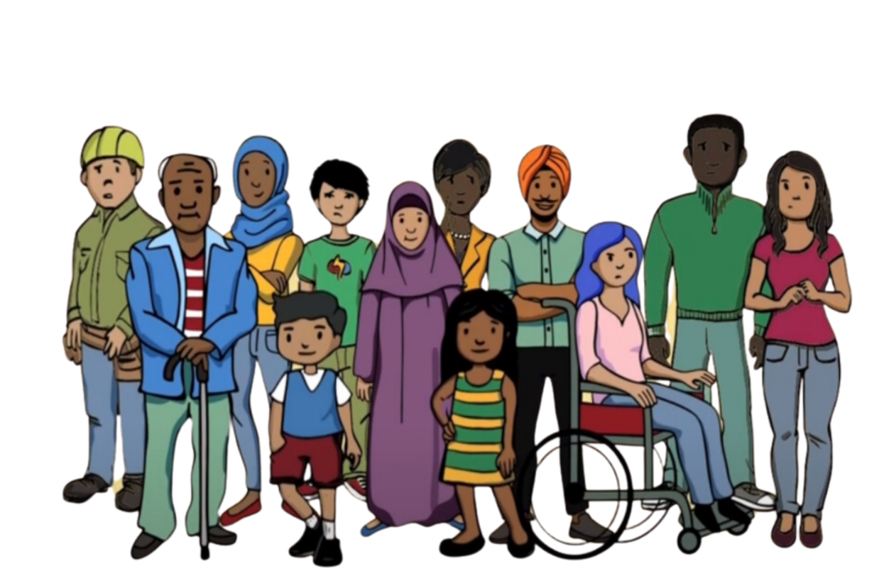

**Example 1**

A community member spoke against their country of origin to the media in New Zealand. After this they got a phone call from their bank in New Zealand, saying their accounts had been frozen because their name was on an international list of people accused of serious crimes. This is called ‘debanking’. They could not access their money because their bank accounts were frozen.

The community member was very concerned because they had not committed any crimes. They believed their name was put on the list by their country of origin to intimidate them and stop them from criticising their country of origin. They felt they had no option but to stop speaking out.

**Example 2**

A community member was approached by someone representing a foreign government. They were told that their family in their country of origin would be harmed unless they joined a group organised by that foreign government. The group’s purpose was to spread political messages within their community in New Zealand on behalf of the foreign state. The community member did not want to join the group, but they were afraid for their family and felt pressured to join to keep their family safe.

Being forced to join the group left the community member feeling threatened and unsafe. They made sure not to say anything that showed they didn’t support the group. They felt unable to express their true views. Their freedom of speech was taken away.

**Exemplo 3**

Uma comunidade étnica organizava um evento cultural. O organizador do evento recebeu a oferta de uma grande doação de alguém representando o governo de seu país de origem. A doação só seria recebida se o organizador compartilhasse informações pessoais sobre as pessoas da sua comunidade.

O organizador ficou muito desconfortável com a oferta. Ele se sentiu pressionado a aceitar a doação para apoiar o evento, mas não queria compartilhar as informações pessoais da comunidade. Quando recusou a doação, ficou amedrontado. Estava preocupado com o que lhe aconteceria por ter dito não. Tornou-se difícil para ele se sentir confortável em sua própria comunidade.

**Example 4**

A community member was having financial difficulties. Someone in their community contacted them on behalf of a foreign state to offer them work. The work was to monitor members of the community in New Zealand and to report them to the foreign state. They wanted to know about anyone who was criticising the foreign state.

The community member was distressed. They did not want to monitor their community. Their financial situation was being used to coerce them. They said no, but were worried about whether anything would happen to them because they had refused. They began to isolate themselves from the community, fearing they might be approached again. They also lost trust in the community, feeling uncertain about who else might be involved in these activities.