Tusaalooyinka faragelinta shisheeye

Tusaalooyinkani waxay ku saleysan yihiin waayo-aragnimada ay Beelaha Qowmiyadaha la wadaageen Wasaaradda Beelaha Qowmiyadaha. Tusaalooyinkan waxa loo bixiyay ujeeddooyin macluumaad iyo waxbarasho oo keliya.

Tusaalooyinkan "dawlad shisheeye" macnaheedu **waa waddan kasta oo aan ahayn   
New Zealand.** Eraygan waxa loo adeegsadaa wadamada ka baxsan New Zealand.

Faragelinta shisheeye waxaa lagu wargelin karaa NZSIS iyo Booliiska. Si aad wax badan uga ogaato ka warbixinta eeg: [Sida loo soo sheego faragelinta shisheeye](https://www.ethniccommunities.govt.nz/programmes/security-and-resilience/how-to-report-foreign-interference/).

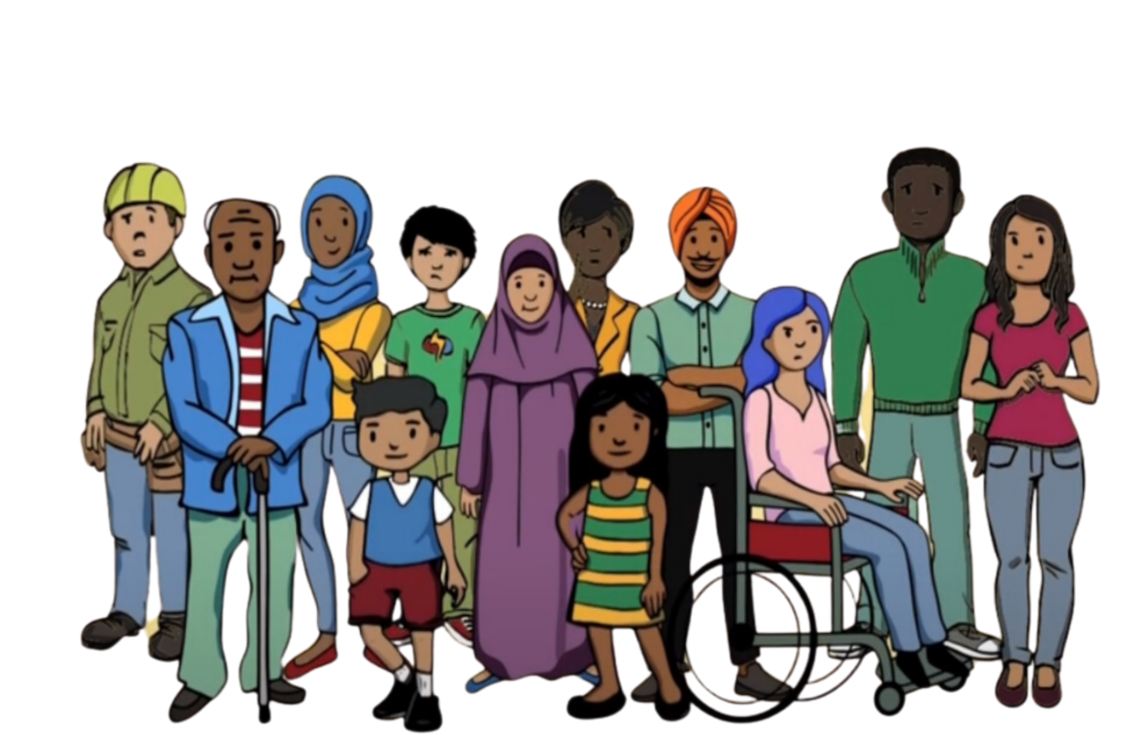

**Tusaale 1**

Xubin ka tirsan jaaliyadda ayaa si xun uga hadlay dalka ay u dhasheen oo warbaahinta kula hadlay New Zealand. Intaa ka dib waxa ay talefan ka heleen bangiga ay ku leeyihiin New Zealand, iyaga oo sheegay in akoonadooda la xayiray, sababtoo ah magacoodu waxa uu ku jiray liiska caalamiga ah ee dadka lagu eedeeyay dambiyada waaweyn. Tan waxaa loo yaqaan 'debanking'. Lacagtoodii way heli kari waayeen sababtoo ah akoonnada bangiyada ayaa la xayiray.

Xubintii bulshadu aad bay uga welwelsanayd sababtoo ah ma aysan gelin wax dembi ah. Waxay aaminsanaayeen in magacooda uu liiska ku daray wadankii ay ka yimaadeen si loo cabsi geliyo loogana joojiyo inay dhaleeceeyaan wadankooda. Waxay dareemeen inaysan haysan wax ikhtiyaar ah oo aan ahayn inay joojiyaan hadalka.

**Tusaale 2**

Xubin ka tirsan beesha ayaa waxaa u yimid qof wakiil ka ah dowlad shisheeye. Waxaa loo sheegay in qoyskooda oo ku nool wadankii ay ka yimaadeen la dhibaateyn doono haddii aysan ku biirin koox ay soo abaabushay dowladdaas shisheeye. Ujeedada kooxdu waxay ahayd inay ku faafiyaan fariimaha siyaasadeed ee bulshadooda ku nool New Zealand iyagoo ka wakiil ah dawladda shisheeye. Xubinta bulshadu ma doonayn inay ku biirto kooxda, laakiin waxay u baqayeen qoyskooda oo waxay dareemeen cadaadis inay ku biiraan si ay qoyskooda u ilaashadaan badbaadada.

Lagu qasbay inuu ku biiro kooxda waxay ka dhigtay xubinta bulshada inay dareemayso hanjabaad iyo ammaan darro. Waxay hubiyeen inaysan sheegin wax muujinaya inaysan taageersanayn kooxda. Waxay dareemeen inay awoodi waayeen inay cabbiraan aragtidooda dhabta ah. Xoriyatul qawlkii waa laga qaaday.

**Tusaale 3**

Bulsho qawmiyad ah ayaa qabanqaabinaysay xaflad dhaqameed. Qabanqaabiyaha xaflada ayaa waxaa ku deeqay deeq aad u badan oo uu bixiyay qof matalayay dowlada wadanka uu ka soo jeedo qabanqaabiyaha. Waxay heli lahaayeen deeqda kaliya haddii qabanqaabiyuhu uu la wadaago macluumaadka shakhsiyeed ee ku saabsan dadka bulshadooda.

Qabanqaabiyuhu aad buu uga xumaaday soo jeedinta. Waxay dareemeen cadaadis ah inay aqbalaan deeqda si ay u taageeraan dhacdada laakiin ma aysan rabin inay wadaagaan macluumaadka shakhsiyeed ee bulshada. Markii ay diideen deeqda, waxay dareemeen cabsi. Waxay ka welweleen waxa ku dhici doona, waayo, maya bay yidhaahdeen. Waxaa ku adkaatay inay ku raaxaystaan bulshadooda.

**Example 4**

A community member was having financial difficulties. Someone in their community contacted them on behalf of a foreign state to offer them work. The work was to monitor members of the community in New Zealand and to report them to the foreign state. They wanted to know about anyone who was criticising the foreign state.

The community member was distressed. They did not want to monitor their community. Their financial situation was being used to coerce them. They said no, but were worried about whether anything would happen to them because they had refused. They began to isolate themselves from the community, fearing they might be approached again. They also lost trust in the community, feeling uncertain about who else might be involved in these activities.