外國干預的案例

以下為少數族裔社區向少數族裔社區部分享的一些受到外國干預的案例。這些事例僅供資訊參考與教育用途。

其中的「外國政府」是指**除紐西蘭以外的任何國家。**此術語用於指代除紐西蘭以外的國家。

可向 NZSIS 和警方舉報外國干預行為。如欲瞭解更多關於舉報的資訊，請參閱：  
[「如何舉報外國干預行為」](https://www.ethniccommunities.govt.nz/programmes/security-and-resilience/how-to-report-foreign-interference/)。

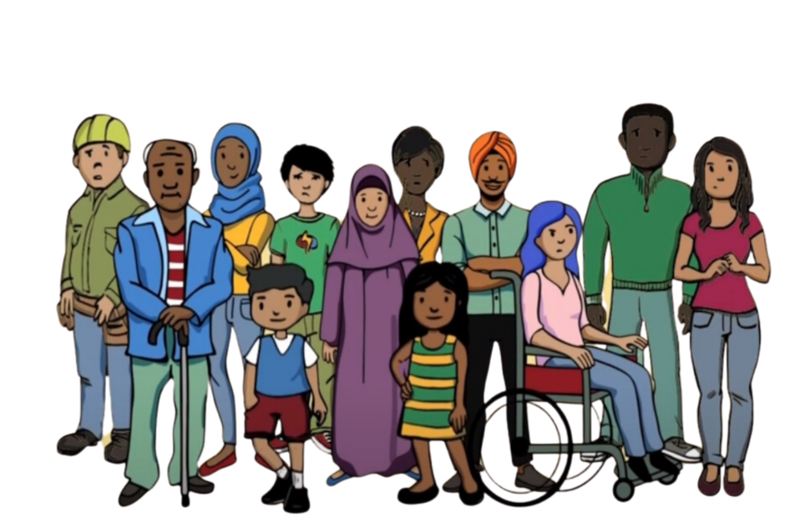

**Example 1**

A community member spoke against their country of origin to the media in New Zealand. After this they got a phone call from their bank in New Zealand, saying their accounts had been frozen because their name was on an international list of people accused of serious crimes. This is called ‘debanking’. They could not access their money because their bank accounts were frozen.

The community member was very concerned because they had not committed any crimes. They believed their name was put on the list by their country of origin to intimidate them and stop them from criticising their country of origin. They felt they had no option but to stop speaking out.

**Example 2**

A community member was approached by someone representing a foreign government. They were told that their family in their country of origin would be harmed unless they joined a group organised by that foreign government. The group’s purpose was to spread political messages within their community in New Zealand on behalf of the foreign state. The community member did not want to join the group, but they were afraid for their family and felt pressured to join to keep their family safe.

Being forced to join the group left the community member feeling threatened and unsafe. They made sure not to say anything that showed they didn’t support the group. They felt unable to express their true views. Their freedom of speech was taken away.

**Example 3**

An ethnic community was organising a cultural event. The event organiser was offered a large donation by someone representing the government of the organiser’s country of origin. They would only get the donation if the organiser shared personal information about people in their community.

The organiser was very uncomfortable about the offer. They felt pressure to accept the donation to support the event but didn’t want to share the community’s personal information. When they turned down the donation, they felt scared. They were worried about what would happen to them because they had said no. It became difficult for them to feel comfortable in their own community.

**Example 4**

A community member was having financial difficulties. Someone in their community contacted them on behalf of a foreign state to offer them work. The work was to monitor members of the community in New Zealand and to report them to the foreign state. They wanted to know about anyone who was criticising the foreign state.

The community member was distressed. They did not want to monitor their community. Their financial situation was being used to coerce them. They said no, but were worried about whether anything would happen to them because they had refused. They began to isolate themselves from the community, fearing they might be approached again. They also lost trust in the community, feeling uncertain about who else might be involved in these activities.