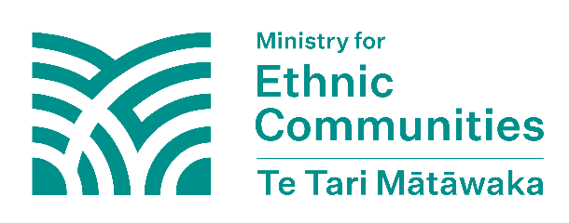
Online abuse and harassment
What is online abuse and harassment?
Online abuse and harassment is when someone uses the internet or social media to harass, intimidate, bully or threaten another person. This can happen through messages, posts, or other online actions that make the person feel upset, scared, or unsafe.
If online abuse or harassment is carried out for or on behalf of a foreign state, this is a form of foreign interference. Online abuse and harassment can be distressing. It’s important to know how to stay safe, what support is available, and what you can do if you or your community are abused and harassed online.
What to do if you’ve been harassed or threatened online
Limit your contact with the person or account
Phone calls and text messages
Use the settings in your phone to ‘block contact’. If this does not work, contact your phone company to block the number.
Online abuse or harassment
Update your privacy settings. Netsafe provides social media guides that help you with privacy settings.
Report it if you have received anything that makes you feel unsafe, or you feel harassed, intimidated or bullied.

Report to Netsafe
- Netsafe can give you expert advice and assistance on online safety.
- Email help@netsafe.org.nz or text ‘Netsafe’ to 4282 to get support.
- You can also ask for support on their website: Submit a request – Netsafe

Reporting on the platform/website/app where it happened
Use the reporting feature on the website, app, or platform where the incident happened. Netsafe’s social media guides have information on how to do this.


Report to Netsafe
You can report harmful content to Netsafe: Submit a request – Netsafe.
Netsafe can also give you expert support, advice and assistance on online safety.
Email help@netsafe.org.nz or text ‘Netsafe’ to 4282 to get support.
Report it to the Police
If you are in danger, call the Police immediately by calling 111.
If it’s not an emergency, you can contact the Police by:
- Using the 105 online form
- Calling 105 from any mobile or landline, this service is free and available 24/7 nationwide.
The 105 form asks for some of your personal information to help the Police process your report and follow up with you. The Police only use this information for permitted purposes.
Report to NZSIS
If you suspect a foreign state is behind the abuse or harassment, you can report this to the NZSIS using their secure online form.
You don’t have to give your personal information like your name, phone number, or contact details if you don’t want to. You can also fill out the form in your own language. All information you provide is confidential and protected.
If you want to talk to someone at NZSIS, you can call them on +64 4 472 6170 or 0800 747 224.

Information to share with Netsafe, Police or NZSIS
when reporting
When reporting, it's helpful to include as many details as possible. Try to screenshot or save a copy of:
- What the content says or shows
- The user profile or account of who abused or harassed you (e.g. their username)
- The date and time the abuse or harassment was received
- The name of the website or app where it happened

Keeping safe online
Look at Keeping Safe Online for more information on what steps you should take to stay safe online.

