Ingero zo kwivanga kw’abanyamahanga

Dore zimwe mu ngero z’ivanga ry’amahanga ryahuye n’imiryango ishingiye ku moko basangiye na minisiteri ishinzwe amoko. Izi ngero zitangwa kubwamakuru no kwigisha gusa.

Muri izi ngero, "leta y’amahanga" bivuga **igihugu icyo ari cyo cyose kitari Nouvelle-Zélande.** Iyi mvugo ikoreshwa mu kuvuga ibihugu byo hanze ya Nouvelle-Zélande.

Kwivanga kwamahanga birashobora kumenyeshwa NZSIS na Polisi. Kugira ngo umenye byinshi kubyerekeye gutanga raporo reba: [Nigute watanga amakuru yivanga mumahanga](https://www.ethniccommunities.govt.nz/programmes/security-and-resilience/how-to-report-foreign-interference/).

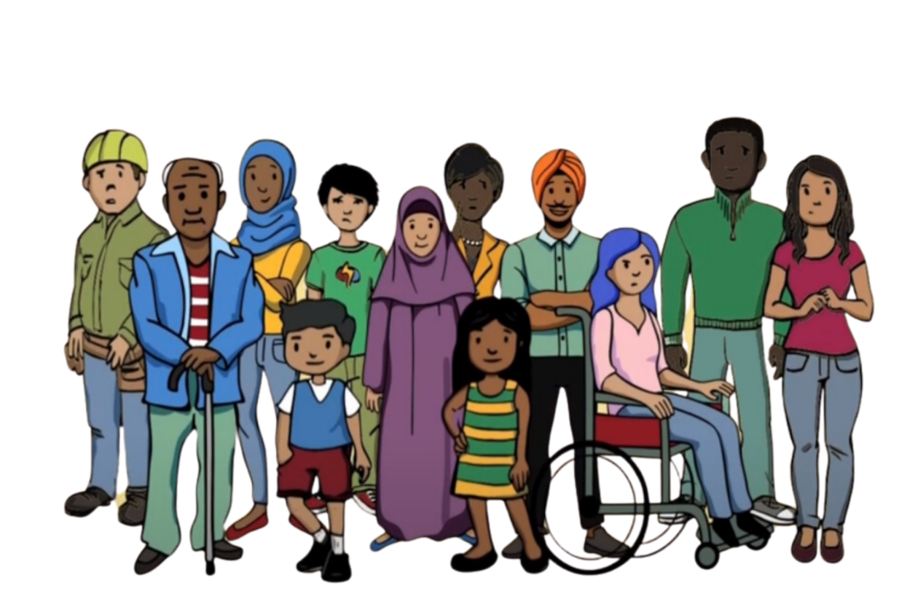

**Urugero 1**

Umuganda umwe yamaganye itangazamakuru muri Nouvelle-Zélande kurwanya igihugu bakomokamo. Nyuma yibi babonye terefone kuri banki yabo muri Nouvelle-Zélande, bavuga ko konti zabo zahagaritswe kubera ko izina ryabo ryari ku rutonde mpuzamahanga rw’abantu baregwa ibyaha bikomeye. Ibi byitwa ’debanking’. Ntibashoboye kubona amafaranga yabo kubera ko konti zabo muri banki zahagaritswe.

Umuganda yari afite impungenge cyane kuko nta cyaha bakoze. Bizeraga ko izina ryabo ryashyizwe ku rutonde n’igihugu bakomokamo kugira ngo babatera ubwoba kandi bababuze kunegura igihugu bakomokamo. Bumvaga nta kundi bari kubigenza uretse guhagarika kuvuga.

**Urugero 2**

Umuganda yegereye umuntu uhagarariye guverinoma y’amahanga. Babwiwe ko umuryango wabo mu gihugu bakomokamo uzagirirwa nabi keretse binjiye mu itsinda ryateguwe n’iyo guverinoma y’amahanga. Itsinda ryari rigamije gukwirakwiza ubutumwa bwa politiki mu gace batuyemo muri Nouvelle-Zélande mu izina ry’amahanga. Umuganda ntiyifuzaga kwinjira muri iryo tsinda, ariko batinyaga umuryango wabo kandi bumva bahatiwe kwinjira kugira ngo umuryango wabo urindwe umutekano.

Guhatirwa kwinjira muri iryo tsinda byatumye abaturage bumva bafite ubwoba kandi nta mutekano bafite. Biyemeje kutavuga ikintu cyose cyerekana ko badashyigikiye itsinda. Bumvaga badashoboye kwerekana ibitekerezo byabo. Ubwisanzure bwabo bwo kuvuga bwambuwe.

**Urugero 3**

Umuryango w’amoko wateguraga ibirori byumuco. Uwateguye ibirori yahawe impano nini numuntu uhagarariye guverinoma yigihugu kavukire. Babona gusa impano mugihe uwateguye asangiye amakuru yihariye kubantu batuye.

Uwayiteguye ntiyorohewe cyane no gutanga. Bumvise igitutu cyo kwakira impano yo gushyigikira ibirori ariko ntibashaka gusangira amakuru yihariye yabaturage. Igihe banze impano, bumvise bafite ubwoba. Bahangayikishijwe nibizababaho kuko bari baravuze ngo oya. Byabagoye kumva bamerewe neza mumiryango yabo.

**Urugero 4**

Umuryango umwe wagize ibibazo byamafaranga. Umuntu mu gace batuyemo yabahamagaye mu izina ry’amahanga kugira ngo abahe akazi. Akazi kwari ugukurikirana abagize umuryango muri Nouvelle-Zélande no kubamenyesha ibihugu by’amahanga. Bashakaga kumenya umuntu wese wanenze igihugu cyamahanga.

Umunyamuryango yari afite agahinda Ntibashakaga gukurikirana umuryango wabo. Ibibazo byabo byubukungu byakoreshwaga kubahatira. Bati oya, ariko bahangayikishijwe no kumenya niba hari ibizababaho kuko bari babyanze. Batangiye kwitandukanya n’abaturage, batinya ko bazongera kubegera. Batakaje kandi icyizere mu baturage, bumva batazi neza undi muntu ushobora kugira uruhare muri ibyo bikorwa.