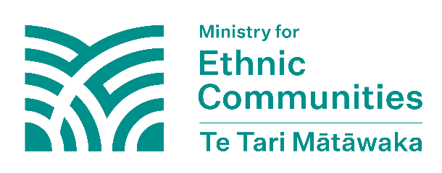
Kwivanga kw’amahanga muri New Zealand
Serivisi ya New Zealand Ishinzwe Umutekano n’Ubutasi (NZSIS) isobanura kwivanga kw’abanyamahanga nk’igikorwa cya leta y’amahanga, akenshi kibinyujije ku wundi muntu cyangwa itsinda rikibereye intumwa, kigamije kugira ingaruka, guhungabanya cyangwa kudindiza inyungu za New Zealand mu buryo bw’amayeri, uburiganya, cyangwa igitugu. Ibikorwa bisanzwe bya dipolomasi cyangwa ububanyi n’amahanga, kugaragaza ibitekerezo binyuze mu nzira zemewe n’ibindi bikorwa bifatika kandi bigaragara bigamije kugira icyo bihindura ntibifatwa nko kwivanga.
Muri uru rupapuro rutanga amakuru, “igihugu cy’amahanga” bivuga igihugu icyo ari cyo cyose kitari New Zealand. Iyi mvugo ikoreshwa mu kuvuga ibihugu byo hanze ya New Zealand.

Kwivanga kw’abanyamahanga byica uburenganzira n’ubwisanzure bw’Imiryango y’Abakomoka hanze ya New Zealand
Kwivanga kw’abanyamahanga ni igihe ibihugu by’amahanga bigerageza kwivanga mu bikorwa bya New Zealand kugira ngo bigere ku ntego zabyo bwite. Ibyo bihugu by’amahanga bigamije kugenzura no guhindura inyungu n’imyitwarire ya sosiyete ya New Zealand. Babikora kugira ngo barusheho kugira ibyo bahindura no kugenzura.

Kwivanga kw’abanyamahanga byangiza ubwigenge, demokarasi, isura yayo ndetse n’imiryango bya New Zealand. Imiryango y’Abakomoka hanze ya New Zealand muri New Zealand ishobora guhura no gukurikiranwa bidakenewe biturutse ku bihugu by’amahanga, bigatuma bumva batari mu mutekano kandi bikangiza uburenganzira n’ubwisanzure bwabo. Ibikorwa bisanzwe bya dipolomasi hagati y’ibihugu ntibifatwa nko kwivanga kw’abanyamahanga.


Ni gute kwivanga kw’abanyamahanga bishobora kubaho ku Miryango y’Abakomoka hanze ya New Zealand?

Kwivanga kw’abanyamahanga ku Miryango y’Abakomoka hanze ya New Zealand muri New Zealand bishobora kuba bigoye kubibona. Dore ingero zimwe z’ibikorwa byo kwivanga kw’abanyamahanga bikorwa na leta y’amahanga cyangwa umuntu ukorera leta y’amahanga kwivanga mu buzima muri New Zealand:

- bagerageza kugenzura no gutera ubwoba imiryango cyangwa amashyirahamwe y’imiryango/amatsinda
- kwanga gutanga cyangwa gutunganya inyandiko zemewe kugira ngo batoteze, batera ubwoba, kandi bagenzure imiryango n’ibikorwa byayo
- kwambura cyangwa gutera ubwoba bwo kwamburwa viza, pasiporo, cyangwa izindi nyandiko zemewe ku bantu bari muri New Zealand kugira ngo batoteze, batera ubwoba, kandi bagenzure ibikorwa byabo
- gutera ubwoba abantu bari muri New Zealand cyangwa imiryango yabo iri mu mahanga (harimo no gukoresha iterabwoba binyuze ku mbuga nkoranyambaga)
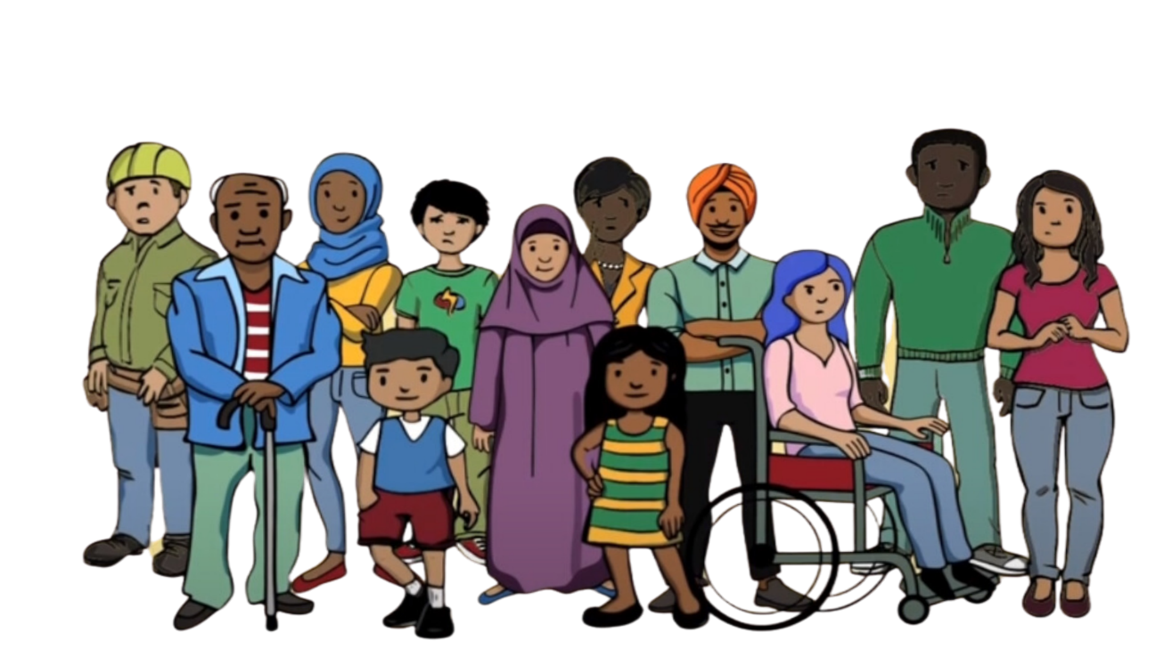
- guhatira abantu gusubira mu gihugu bakomokamo ku ngufu, batabishaka
- kugenzura no gukurikirana imiryango mu buryo butemewe n’amategeko bikozwe n’igihugu cy’amahanga hagamijwe gutera ubwoba cyangwa gutoteza abantu
- kugerageza guhagarika amatsinda cyangwa imiryango kugira ngo batavuga ibitekerezo byabo cyangwa ibyo bemera ku mugaragaro igihe bidahuye niby’igihugu cy’amahanga bakoresheje iterabwoba cyangwa gukanga
- kugerageza guhagarika ibikorwa bibera mu gihugu cya New Zealand kugira ngo abantu batagaragaza ibitekerezo cyangwa imyemerere igihugu cy’amahanga kidashyigikiye
- gutambutsa ubutumwa bw’iterabwoba biva mu gihugu cy’amahanga bikagezwa ku miryango iri muri New Zealand
- gukora ibishoboka ngo bahindure imikorere y’amatora cyangwa izindi nzira za demokarasi

